TWYFORD PARISH COUNCIL
Minutes of a meeting of the Full Parish Council
held on Thursday 19th July 2018 at 7.30 p.m. in the Gilbert Room of Twyford Parish Hall

Councillors present | Councillors absent/apologies | In attendance
Councillor Lawton (Chair) | Councillor Humby | Jo Nicholson (Clerk)
Councillor Mitchell | Councillor West (Maternity Leave) | 1 member of public (until item 92/18)
Councillor Wheeler | Councillor Pain (nee Cornwall) | 1 member of public representing Parish Hall
Councillor Sellars |  | Councillor Izard – attended from 8.30pm until item 92/18
Councillor Pullen
Councillor Corcoran
Councillor Forder-Stent
Councillor Cook – attended from 8.30pm until end.

Item | Business Transacted
73/18 | To receive and accept apologies for absence
 | Apologies were received from Cllr Humby, Cllr Pain (nee Cornwall), Cllr Cook, Cllr Izard, and Cllr West is on maternity leave.
74/18 | To receive declarations of interest relevant to agenda items
 | The registered declarations were applied. Cllr Sellars and Cllr Wheeler declared interest in item 84/18, as trustees of the Parish Hall.
75/18 | To approve and sign-off, as a true record, the minutes for the Full Parish Council meeting held on 21st June 2018
 | The minutes from 21st June 2018 were approved as a true record of events proposed by Cllr Forder-Stent and seconded by Cllr Mitchell.
76/18 | To adjourn for public participation
76.1/18 | To receive questions from the members of the public.
 | None received
76.2/18 | To receive the County Councillor’s report.
 | Apologies received
77.3/18 | To receive the District Councillors’ reports.
 | Delayed until 8.30, as Cllr Izard and Cllr Cook at PACT meeting.
77/18 | To receive an update on matters arising from the minutes of the Full Council meeting held on 21st June 2018 that are not included elsewhere on the agenda and to consider the status of progress to date
 | 60/18: Clerk received quotes from Alex Reidy for the tree work at Hunter Park, which was within the approval limits of the Clerk, and the work will be conducted.
77.1/18 | Resolve to approve the Terms of Reference for sub-committee Neighbourhood Plan
 | Carried over – CC gave apologies
78/18 | Review progress to date on previous FPC meeting outstanding actions
 | Carried over
79/18 | To receive an update from the Planning Committee and any updates on any matters arising unless already covered by another agenda item
Cllr Mitchell | No further update since the circulation of the Planning Committee Minutes from 5th July 2018 which the Minutes were circulated to all of the FPC. The status of Highcroft and Hillcroft Appeals were queried.  Action: Cllr Mitchell to look up status of Highcroft and Hillcroft applications
80/18 | To receive an update from the Finance Committee on matters arising; and to note or discuss action taken since unless already covered by another agenda item
 | No further actions in addition to agenda items below.
81/18 | Resolve to approve payments to be made in July 2018
The payments to be made in July were reviewed and approved. Proposed by Cllr Mitchell and seconded by Cllr Corcoran.
Cllr Mitchell raised the point that the Legionella assessment would not be required to be redone, unless significant changes were done to the water system at the pavilion. The Clerk acknowledged and confirmed.
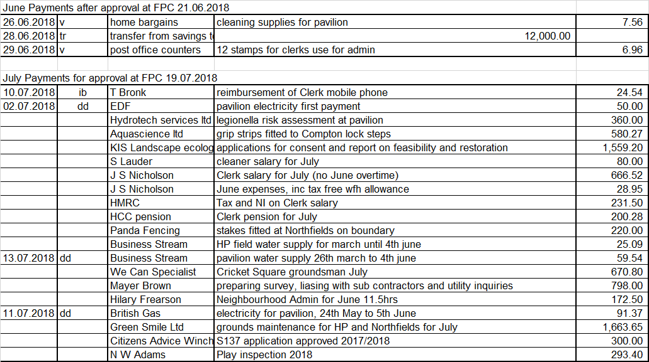

82/18 | Resolve to approve the Q1 financials, and reconcile the bank statement to payments made in the quarter.
 | Cllr Sellars and the Clerk talked through the Q1 financials (see Appendix 1). Following the detailed review at the Finance Committee on 12th July, the FPC resolved to approve the financials, and Cllr Sellars reconciled to the bank statements. Proposed by Cllr Mitchell and seconded by Cllr Corcoran.
83/18 | Resolve to support the production of a 5 year financial plan, initially to support the strategic spend on open spaces and new play assets
Financials to date have been relatively straight forward, and will become more complex over the next 5 years as growing savings for new play equipment, and saving for projects identified from the Neighbourhood Plan needs to be set out. The production of a 5 year plan is supported, and the first step was agreed to be a completion of the top 10 priorities over the coming 5 year period.
Action: Clerk to email Cllrs requesting their priorities, and compile a list.
84/18 | Resolve to approve (or not approve) the S137 application from the Parish Hall Trustees for repair and renovation to the forecourt entrance
Clerk | The treasurer of the Parish Hall Trustees talked through the application for a grant towards the resurfacing of the forecourt to the Parish Hall. It is need of repair, and the Parish Councillors reviewed the proposal.  The forecourt will have a new membrane put down, retaining edge and new shingle. The trustees are also liaising with the surgery to get the side fence replaced. Cllrs requested that it is made clear in the booking conditions that parking at the front of the Hall is restricted to access only and special access. The forecourt is only intended for occasional use, and therefore does not require tarmac.  There is £5,000 budget in the grant / S137 budget for 2018 / 2019. The application for £3,333 would result the majority of the budget being allocated to this application. This application was viewed as important to the whole village, and it was resolved to approve the application. Proposed by Cllr Lawton and seconded by Cllr Forder-Stent.  The Parish Hall trustees were asked by the PC to consider putting tarmac down the side of the building.  The Parish Hall has had wi-fi installed, but are still investigating contracts with providers. The Parish Council will be a major user, so the Trustees will discuss whether the contract is best taken out by the PC.  Action: Clerk to add to next FPC agenda for an update from the Parish Hall Trustees
85/18 | Consider steps required to prepare for insurance renewal due 30th September 2018
Cllr Mitchell  & Clerk  Cllr Lawton | The Clerk and Cllr Wheeler met with the insurance broker Came and Company to discuss the requirements for the renewal due 30th September. It was specified that cover would be required for the new steps at the lock. The broker then queried whether public liability at the lock would actually be covered. The broker confirmed after the meeting, that public liability at Compton lock would not be covered by the policy as the site is advertised as a natural swimming location on various websites (not by TPC). The insurance broker specified that TPC have to display a sign to state swimming is not allowed at the lock.  The Clerk had sought legal advice, who question why the insurance company would not provide public liability cover, as the land is covered on the policy like everywhere else in the parish. However, this is not definite.  The Clerk and Chairman have set out to establish how other organisations insure, when there is water going through a public way. For example, Basingstoke and Winchester City Council do not appear to have signs up next to waterways.  Ian Soulsby had emailed to comment that the water way does not actually belong to TPC, therefore if an accident occurred in the water, it would not be TPC responsibility.  The matter is ongoing, and the following actions were decided:  - Immediate action  Cllr Mitchell to put up a sign at the lock, with new wording to say TPC accept no liability. Cllr Mitchell to send a photo of the sign, and send to the Clerk. Clerk to send photo to insurers for their records.  - Intermediate action (to be done up until end of current insurance policy 30th September)  Cllr Lawton to set up a meeting with HCC Countryside, Cllr Rob Humby, and establish who owns what part of the lock.  - Longer term (at insurance renewal, 30th September)  Specify cover is required on the new policy, and await requirement from the new insurer.  It was agreed that no communication would go out to the village, as the facts were still being established. A public meeting will be arranged for the spring, to discuss with villagers the ownership of the lock, liability and rubbish collection.  Action: Clerk to add as an agenda item to the February 2019 FPC meeting.  Clerk also reported that the council must record risk assessments when a risk / danger has been identified (by member of public or cllr)
86/18 | To receive an update on matters arising from the Recreation Committee; to note or discuss action taken since unless already covered by another agenda item
Cllr Wheeler has received the results of the Legionella risk assessment. He is reviewing the recommendations, to agree actions at the Recreation Committee meeting 2nd August.
Cllr Lawton is trying to make contact with John Paine, to discuss whether Twyford Cricket Club would be interested in taking on the cricket groundsman contract.
87/18 | Resolve to approve Health and Safety policy, and risk assessments procedure. Review the risk assessments required to be completed and assign owners and timetable for delivery
Clerk & Cllr Pullen | Cllr Pullen has compiled a draft H&S policy.  Action: Clerk and Cllr Pullen to meet to review the risk assessments required.  Clerk to circulate H&S policy, and add sign off to the next FPC agenda Sept 2018
88/18 | Review the results of the annual play inspection
 | Cllr Wheeler has received the results of the play equipment assessment. He is reviewing the recommendations, to agree actions at the Recreation Committee meeting 2nd August.
89/18 | Resolve to agree expenditure on a new locking system on the entrance to the pavilion at Hunter Park
Clerk  Clerk | Quotes have been obtained to install a card access system to the pavilion, as it is reported that access is being made to the pavilion between bookings. Quotes suggest £1,500 will be required to install an adequate system. The Cllrs were not convinced that the level of expenditure is necessary, instead the following actions were agreed  Actions:  Clerk to obtain quotes for automatic lights / timer light switches to prevent lights being left on  Clerk to change the lock access code at end of the cricket season, and inform relevant people
90/18 | Councillor Corcoran to provide an update on Berry Meads & Compton Lock Committee and review action list recommended by Kathy Stearne. Review the budget and expenditure to date and resolve to approve the budget for phase 2.
Clerk  Cllr Corcoran | Cllr Corcoran updated on progress and further requirements at the Lock and Meads. A survey is required of the land at the Meadow, as the levels have sunk. A survey of the structures on the meadow is also required. If the land has sunk, then digging will be required to bring them back up, but the land is SSSI, which therefore presents a problem. Cllr Corcoran talked through the expenditure to date on the project, and the projected spend to the end of the project has increased due to additional work identified. The Council questioned how important is it to spend additional funds on this project. Cllr Corcoran specified that no additional funds are required from TPC, and all other funds will come from additional grants.  The following actions were agreed:  Clerk to complete forms required to obtain the agreed funds from SDNPA  Cllr Corcoran to present to the TPC specific figures for each stream of work, with priorities  It was agreed that phase 2 could proceed, only if funding is found from other sources, and no additional cost falls to TPC.
91/18 | Review recent events at the lock and recommend subsequent actions
 | Discussion covered by item 85/18
77.3/18 | To receive the District Councillors’ reports.
Cllr Izard and Cllr Cook arrived after PACT meeting.
Update from Cllr Izard:
Funding from Sandyfields development yet to be received. Some units will be completed in October, so money may be received then.
Speedwatch equipment has been vandalized, so speedwatch has stopped. Colden Common have bought new units.
Colden Common are compiling their response to Eastleigh Local Plan, which they will forward to Twyford when complete. There are still gaps in Eastleigh Local Plan, which they have been unable to answer, for example, there is still confusion over who is approving the proposed new road through Allbrook.
The Local Plan has to reach the inspector by October, so Eastleigh is under a tight timescale.
Update from Cllr Cook:
Cllr Cook had just arrived from a PACT meeting where the Lock and Hunter Park were discussed. The police are trying to maintain a police presence at both sites. They are unable to do anything regarding litter.
There were complaints regarding The Rising SunFest, on 7th July, where loud music was reported. This will be looked at for next year and the license to be agreed.
An event is being held at Highbridge Farm this weekend, and Cllr Cook will give Cllr Lawton the contact number for complaints should there be any whilst clerk is on holiday.
PACT praised Graze festival, how well it has been run in previous years.
The forever festival is still being investigated.
The request was made that if there are any events with fireworks, organisers need to inform people with horses.

92/18 | Resolve to make item 93/18 a confidential item
 | It was resolved to make the next item confidential. Proposed by Cllr Wheeler and seconded by Cllr Forder-Stent. Cllr Izard and members of the public left the meeting.
93/18 | Confidential item: Councillor Corcoran to provide an update on progress of the Neighbourhood Plan and review the draft results of the SEA.
 | The interim results of the SEA were discussed, to remain confidential as changes may yet be made. No actions agreed.
94/18 | Public Transport and Bus Stops – To receive an oral report from Councillor Wheeler
 | Cllr Wheeler reminded that HCC have issued a Consultation on buses being subsidised next year. The Consultation is open until the 5th August 2018. The Consultation also includes Street Lighting. Further information can be found at www.hants.gov.uk/aboutthecouncil/haveyoursay/consultations/publictransportandstreetlighting.
95/18 | Consider status of footpaths, byways and pavements, and report any required maintenance required. Identify priorities for Lengthsman visit 15th August.
Cllr Lawton will contact Twyford School to address the ditch and hedge alongside Hazeley Road.
Cllr Cook will obtain more notices to deter dog mess on the footpath along Upper and Lower Church Path.
It was identified that Upper Church Path may be a good candidate to receive funding from 106 money, as the tarmac surface needs redoing.
96a/18 | Resolve to approve the response to the Eastleigh Local Plan consultation
Clerk | A separate meeting is to be set up for Cllr Cook, Cllr Lawton, Clerk and Cllr Corcoran to devise the response. Delegation was given for the response to be given on behalf of the Council.  Action: Clerk to set up meeting
96b/18 | Update on GDPR implementation plan
 | Clerk has been working with Edge IT contractors to set up shared drive and mailboxes, next meeting with Edge is 1st August.
97/18 | Update on Pumfrett’s Bank from Cllr Lawton
 | The owner of Pumfrett’s Bank has appointed a Solicitor, who has written to Waine stating the bank has nothing to do with the PC. Cllr Lawton has sent the letter on to HCC solicitors and we await a reply from them. If we pursue any further with a local lawyer, who has been advising for free to date, it will cost. It was agreed not to take further action until we hear back from HCC.
98/18 | To note, for information only, significant communications on matters that are not included elsewhere on the agenda
 | None raised
99/18 | To raise any items for the agenda for the Full Parish Council meeting 20th September 2018 and consider contingency for urgent matters during Clerk holidays, and August when there are no meetings.
 | Chris Mitchell to be the Out of Office contact on Clerk email during Clerk’s holiday in July.

Jo Nicholson - Clerk to the Parish Council – 15th August 2018. Contact: clerk@twyfordhants.org.uk

Appendix 1 – Q1 financials