TWYFORD PARISH COUNCIL
Minutes of a meeting of the Full Parish Council
held on Thursday 20th September 2018 at 7.30 p.m. in the Gilbert Room of Twyford Parish Hall

Councillors present | Councillors absent/apologies | In attendance
Councillor Lawton (Chair) | Councillor Humby | Jo Nicholson (Clerk)
Councillor Mitchell | Councillor West (Maternity Leave) | Councillor Izard
Councillor Wheeler | Councillor Pain (nee Cornwall) | 1 member of public
Councillor Sellars | Councillor Corcoran
Councillor Pullen
Councillor Cook
Councillor Forder-Stent

Item | Business Transacted
100/18 | To receive and accept apologies for absence
 | Apologies were received from Cllr Humby, Cllr Pain (nee Cornwall), Cllr Corcoran, and Cllr West is on maternity leave.
101/18 | To receive declarations of interest relevant to agenda items
 | The registered declarations were applied. Cllr Sellars and Cllr Wheeler declared interest in item 109/18, as trustees of the Parish Hall.
102/18 | To approve and sign-off, as a true record, the minutes for the Full Parish Council meeting held on 19th July 2018
 | The minutes from 19th July 2018 were approved as a true record of events proposed by Cllr Wheeler and seconded by Cllr Forder-Stent.
103/18 | To adjourn for public participation
103.1/18 | To receive questions from the members of the public.
 | Correspondence received to request moving the weight limit sign of 7.5 tonnes from Mare Lane further up Hazeley Road, towards the village before Humphrey Farms.
The member of public attended and discussed the correspondence they had raised above. It was agreed that the Parish Council would move this forward, and take the proposal to Cllr Humby.
Action: PC to progress and raise with Cllr Humby
103.2/18 | To receive the County Councillor’s report.
 | Apologies received
103.3/18 | To receive the District Councillors’ reports.
Clerk | Cllr Izard proceeded to provide an update on district matters.  The Boundary Commission has been formulated, and Twyford and Colden Common will now become under Test Valley, and there is no right of Appeal in the decision. The final step is a vote by MP’s. In reality, Twyford would still need to deal with Steve Brine, as part of Winchester.  Eastleigh Local Plan will repot to Council in October, so submit the plan. WCC have raised concerns regarding the Highway proposal in Allbrook, which Eastleigh have said they will look into, but the report will not be available until after the Plan has been submitted.  Winchester Local Plan is up for an update to 2036. 653 houses are to be allocated across Winchester, some will go to South Downs, Denmead and Twyford.  Winchester Leisure Centre development is still ongoing, the next set of plans will come out in November.  Southampton Airport is set to double in size.  Action: Clerk to add to the Planning Committee 4th October  Cllr Cook, in addition to supporting the above, added that she had attended and participated in the Heritage open day in Winchester, which was very well done.
104/18 | To receive an update on matters arising from the minutes of the Full Council meeting held on 19th July 2018 that are not included elsewhere on the agenda and to consider the status of progress to date
 | It was commented that the surfacing work at the front of the Parish Hall has been completed, and looks great. The question was asked if the fence next to the surgery is being repaired. Cllr Wheeler reported that the surgery are planning to fix it.
104.1/18 | Resolve to approve the Terms of Reference for sub-committee Neighbourhood Plan
 | Carried over – CC gave apologies
78/18 | Review progress to date on previous FPC meeting outstanding actions
 | Carried over
105/18 | Councillor Corcoran to provide an update on progress of the Neighbourhood Plan
Clerk | South Down’s comments on the TNP feedback on the SEA have been received. The TNP are reviewing the feedback, and there is a meeting on 5th October with South Down’s to either accept of reject the proposed changes.  Mayer Brown have been doing the model of the drains, based on the survey work. The drain survey team discovered huge amounts of mess in the drains, which they cleared out. This has an impact in that there will be additional cost for that work, but also, it means that this work had not been done effectively previously by HCC.  Cllr Cook requested communication to go out to the village via TIS. The Clerk has drafted an update, which is waiting for approval from Cllr Corcoran.  Action: Clerk to send out update on NP following approval from Cllr Corcoran
106/18 | To receive an update from the Planning Committee and any updates on any matters arising unless already covered by another agenda item
106.1/18 | Resolve to object or not object to planning application SDNP/18/04558/HOUS, Eaton House Bourne Fields Twyford Winchester Hampshire SO21 1NY, conversion of existing garage to bedsit, which has a response date due by 28th September 2018
 | It was resolved that the Parish Council do not object to the application, seconded by Cllr Wheeler.
106.2/18 | Resolve to delegate Cllr Corcoran to make Twyford Parish Council representation at South Downs National Park Local Plan hearing.
 | This was discussed and supported by the Parish Council, proposed by Cllr Lawton and seconded by Cllr Mitchell
106.3/18 | FPC to endorse response required to Winchester Local Plan Consultation, due to be submitted by 20th September
The submission from Cllr Corcoran was reviewed, it was supported for the Clerk to make final edit of the comments and submit to WCC on behalf of the Parish Council. Proposed by Cllr Lawton and seconded by Cllr Forder Stent.
Action: Clerk to make final edit and submit comments on WLP Consultation.
The SHLAA consultation was also made available at the same time.
Action: Clerk to obtain the comments made by Colden Common and send to Cllr Corcoran and Cllr Lawton.
107/18 | To receive an update from the Finance Committee on matters arising; and to note or discuss action taken since unless already covered by another agenda item
 | No further actions in addition to agenda items below.
107.1/18 | Results on external audit, and next steps
The external audit has been completed, and there was an exception on the report, which made mention that Section 2 of the AGAR was dated signed prior to the date Section 1 was signed.
The AGAR will be displayed on all 3 notice boards, and on the Parish Council website. The charge for any request of printing will be £1 per request.
108/18 | Resolve to approve payments to be made in September 2018, and review invoices received since the last FPC meeting, 19th July 2018.
August payments
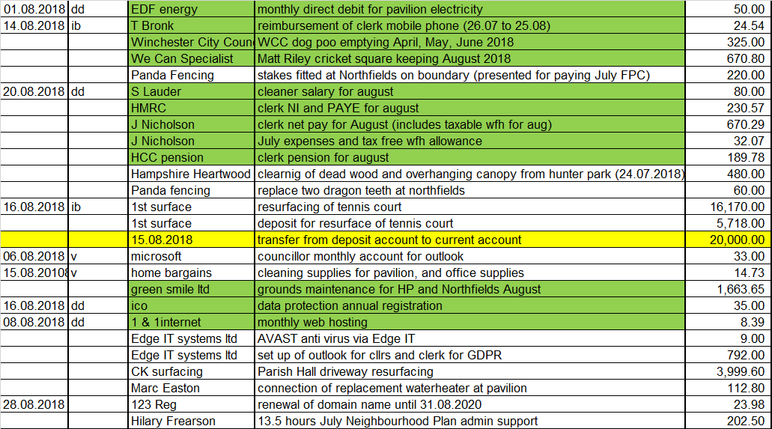

September payments
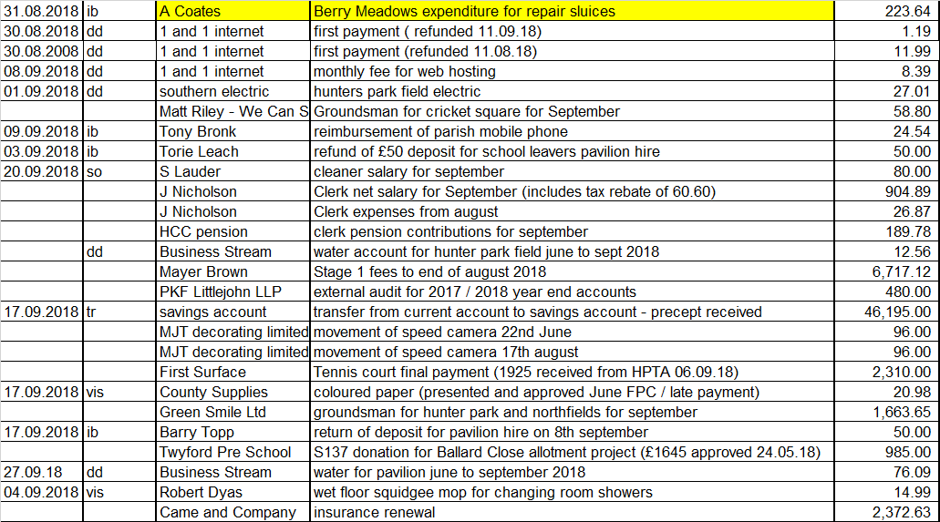

The insurance renewal is pending discussion in item 110/18. All other payments were discussed, reviewed and resolved to make payments accordingly, proposed by Cllr Lawton and seconded by Cllr Cook.
109/18 | Resolve to approve (or not approve) the second S137 application from the Parish Hall Trustees for repair and renovation to the forecourt entrance.
 | The Parish Council agreed on 19th July 2018, item 84/18 to donate £3,333 to the Parish Hall to renovate the entrance to the Hall. Through discussion of the needs of all users of the Hall, it was since decided by the Parish Hall trustees, to extend the tarmac to the front door of the Hall, thus making it more accessible by people with all needs. The Parish Hall trustees have funded half of the additional cost, leaving £1,500 plus VAT to pay. For the benefit of all of the Parish, the Parish Council resolved to fund the £1,500 out of the S137 fund (the Parish Hall falls out of S137, and is classified under Grants and donations). Proposed by Cllr Lawton and seconded by Cllr Cook.
110/18 | Resolve to approve the Parish Council insurance renewal, due 30th September 2018.
Cllr Cook  Clerk | The Parish Council insurance is due to complete the 3 year agreement with HIscox on 30th September. Previous discussion with the broker, Came & Company has identified the newly renovated dog steps into the lock as an issue for the insurance providers. The quotes offered at renewal state particular conditions regarding the lock, and the requirements of the Council. Cllr Mitchell has been in discussion with HCC regarding stretches of land they own that borders water, and what advice can they provide. The investigations are still ongoing. Therefore, it was resolved for the Clerk to request a 1 month cover note on the existing policy, to enable the completion of investigations with HCC. It was delegated for the Clerk to pay for the extension of cover on a pro rata basis to the existing cover. Proposed by Cllr Mitchell and seconded by Cllr Lawton.  Actions  Cllr Cook to email Cllr Warwick to obtain an update, and explain delay in correspondence with Clerk and Cllr Mitchell  Clerk to obtain cover note for one month
 | Cllr Izard left the meeting at 8.45pm
111/18 | To receive an update on matters arising from the Recreation Committee; to note or discuss action taken since unless already covered by another agenda item
The fencing on boundary of the cricket pitch at Hunter Park is due to be repaired on 10th October by Brooks fencing.
The cricket groundsman is leaving on 30th September, and the process to appoint the new contractor will be agreed at the Recreation Committee 27th September.
111.1/18 | Resolve to approve expenditure on chafer grub treatment at Hunter Park, £568 plus VAT
 | It was resolved to proceed with the chafer grub quote at £568, plus VAT. Proposed by Cllr Wheeler, seconded by Cllr Lawton
112/18 | Resolve to approve the Parish risk assessment conducted by Cllr Pullen and Clerk
 | The Risk Assessment (appendix 1) was presented by Cllr Pullen and approval resolved, proposed by Cllr Mitchell, seconded by Cllr Lawton.
113/18 | Councillor Corcoran to provide an update on Berry Meads & Compton Lock Committee.
Clerk | In Cllr Corcoran’s absence, the Clerk and Cllr Mitchell updated from the BM&CL Committee meeting on 16th August 2018.  There are two gates on the Meadow, only one of which will be repaired, the other will be closed off, and any complaints will be monitored. The Parish Council supported this action by initially using cable ties.  The Clerk will send out an update on TIS to communicate with the village the progress on work on the lock and meadows, and the work of volunteers at the lock over the summer.  Action: Clerk to send out TIS on developments at the lock and water meadows
114/18 | Update on GDPR implementation plan and the migration to new Parish Council email addresses for Clerk and Cllr’s. Resolve to agree a cut off date that all emails on Council matters will no longer be sent to the Cllr’s personal email addresses
Cllr Sellars and Cllr Cook is yet to complete the email migration, and it is unknown about Cllr Pain.
Action: Clerk to send Cllr Cook Edge IT contact number
It was agreed that the Clerk would cease to use personal email addresses from 1st October 2018.
115/18 | Update on Eastleigh Local Plan
Cllr Lawton updated that SDNP have provided a response on ELP.
It was also commented that some of the banners around the village and in Colden Common are looking out of date
Action: Cllr Lawton to feedback to ADD the banners look out of date
116/18 | Consider status of footpaths, byways and pavements, and report any required maintenance required.  - Cllr Cook to update on progress with WCC in cutting the hedge back along Finches Lane down from the cross roads  - Cllr Pullen to propose improvements to the corner of Finches Lane / Queen Street  - Riparian ditch clearing, annual reminder to Parish.
Cllr Cook updated that Cllr Humby has promised Finches Lane will be addressed.
Action: Cllr Cook to follow up with Cllr Humby the progress on the hedge at Finches Lane
The corner of Finches Lane / Queen Street it was agreed, needs to be tidied up
Action: Cllr Cook to contact Ivan Gurdler to assess the tree for cutting back. Cllr Cook to enquire about moving the dog bin away from the bench, and further up the bank.
The Clerk has sent out a communication to the village on Riparian ownership, and ditch clearing. The ditch on Segars Lane has been cleared of overgrowth by the ditch owner. The ditch however appears to be blocked.
117/18 | Public Transport and Bus Stops – To receive an oral report from Councillor Wheeler
 | Cllr Wheeler is waiting to hear back from the public transport consultation which closed in August.
118/18 | Review progress to date on previous FPC meeting outstanding actions
 | See Appendix 2.
119/18 | To note, for information only, significant communications on matters that are not included elsewhere on the agenda
The Clerk updated on a complaint received back in July regarding the over grown hedge along Hazeley Road. This has been cut back by the School.
Cllr Lawton updated on Pumphrett bank, which is looking unkempt and overgrown. Cllr Lawton has written to HCC Solicitor to chase a reply. The Council have been advised that the Council has a right to tidy up the bank.
Cllr Cook enquired about the wedding request for a marquee at Hunter Park next summer. The Clerk updated that the hire cost proposed had meant the couple no longer wanted to pursue it as an option. The Clerk had offered to discuss the price with the Parish Council, which the hirer declined.
120/18 | To raise any items for the agenda for the Full Parish Council meeting 18th October 2018.
 | Commencing budget process, all sub committees to formulate requirements to bring to the next FPC.

Jo Nicholson - Clerk to the Parish Council – 25th September 2018. Contact: clerk@twyfordhants.org.uk

Appendix 1 – Risk Assessment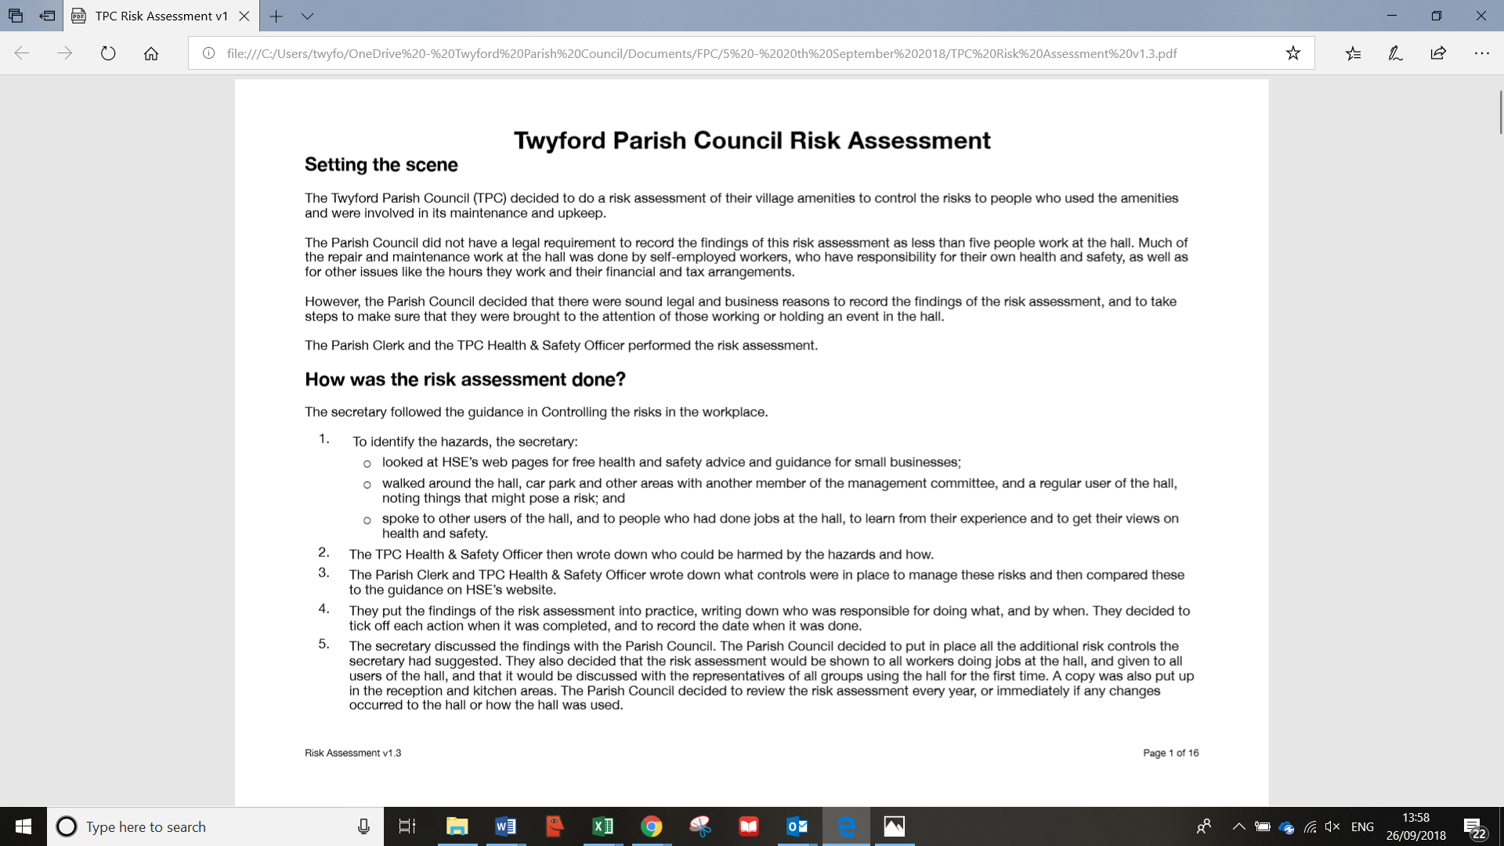
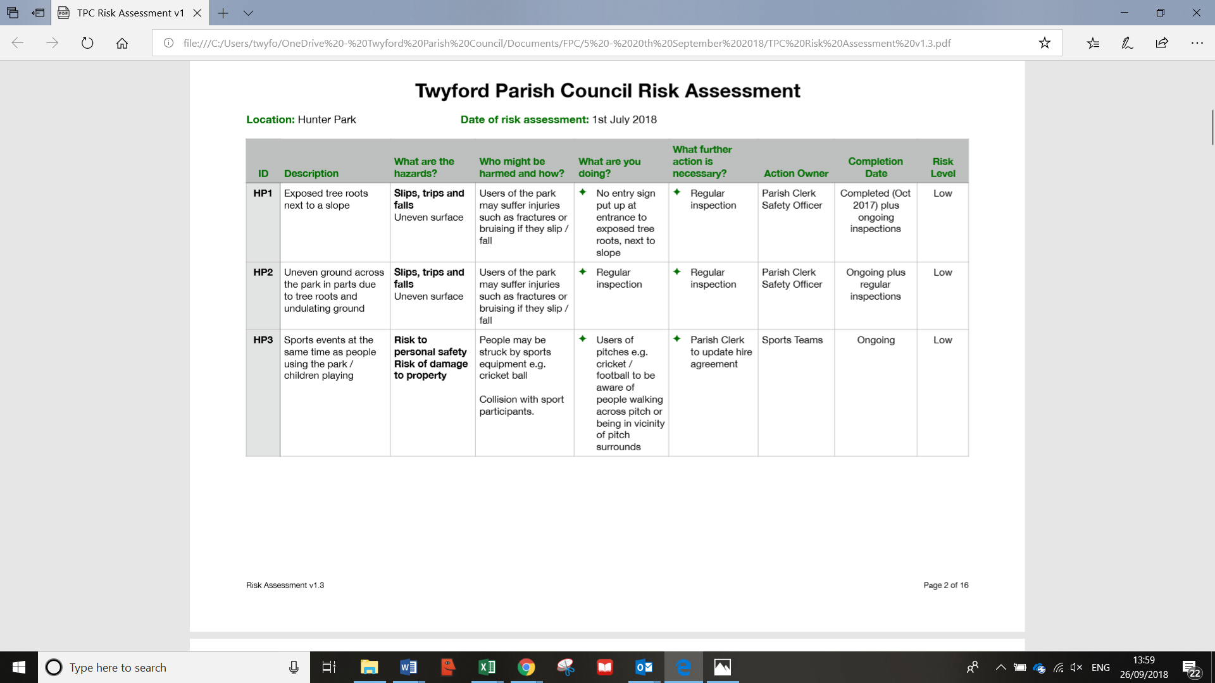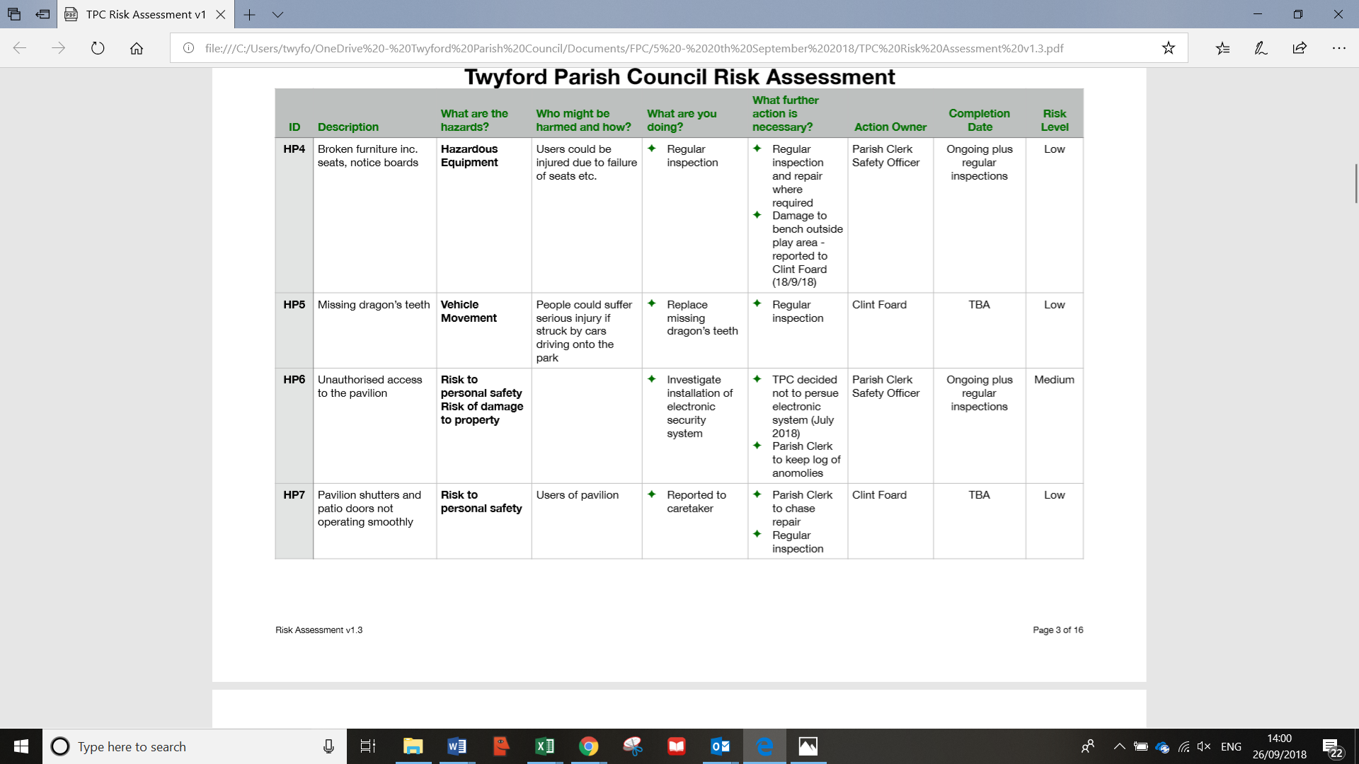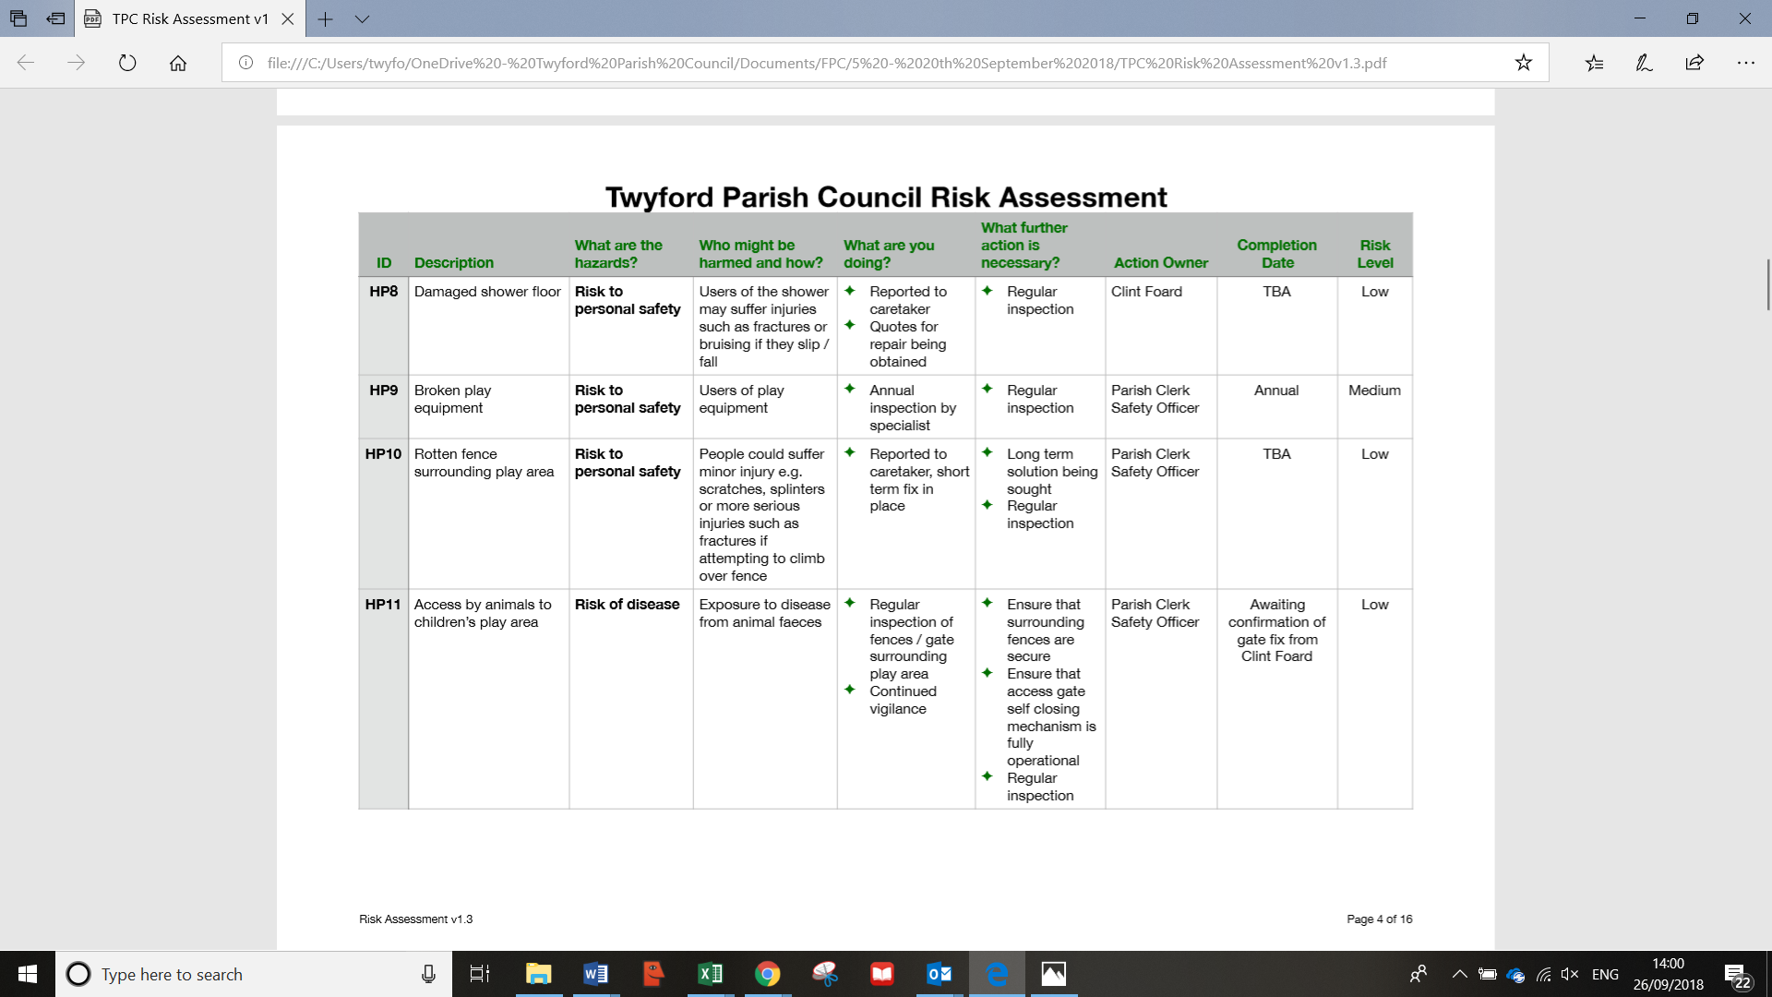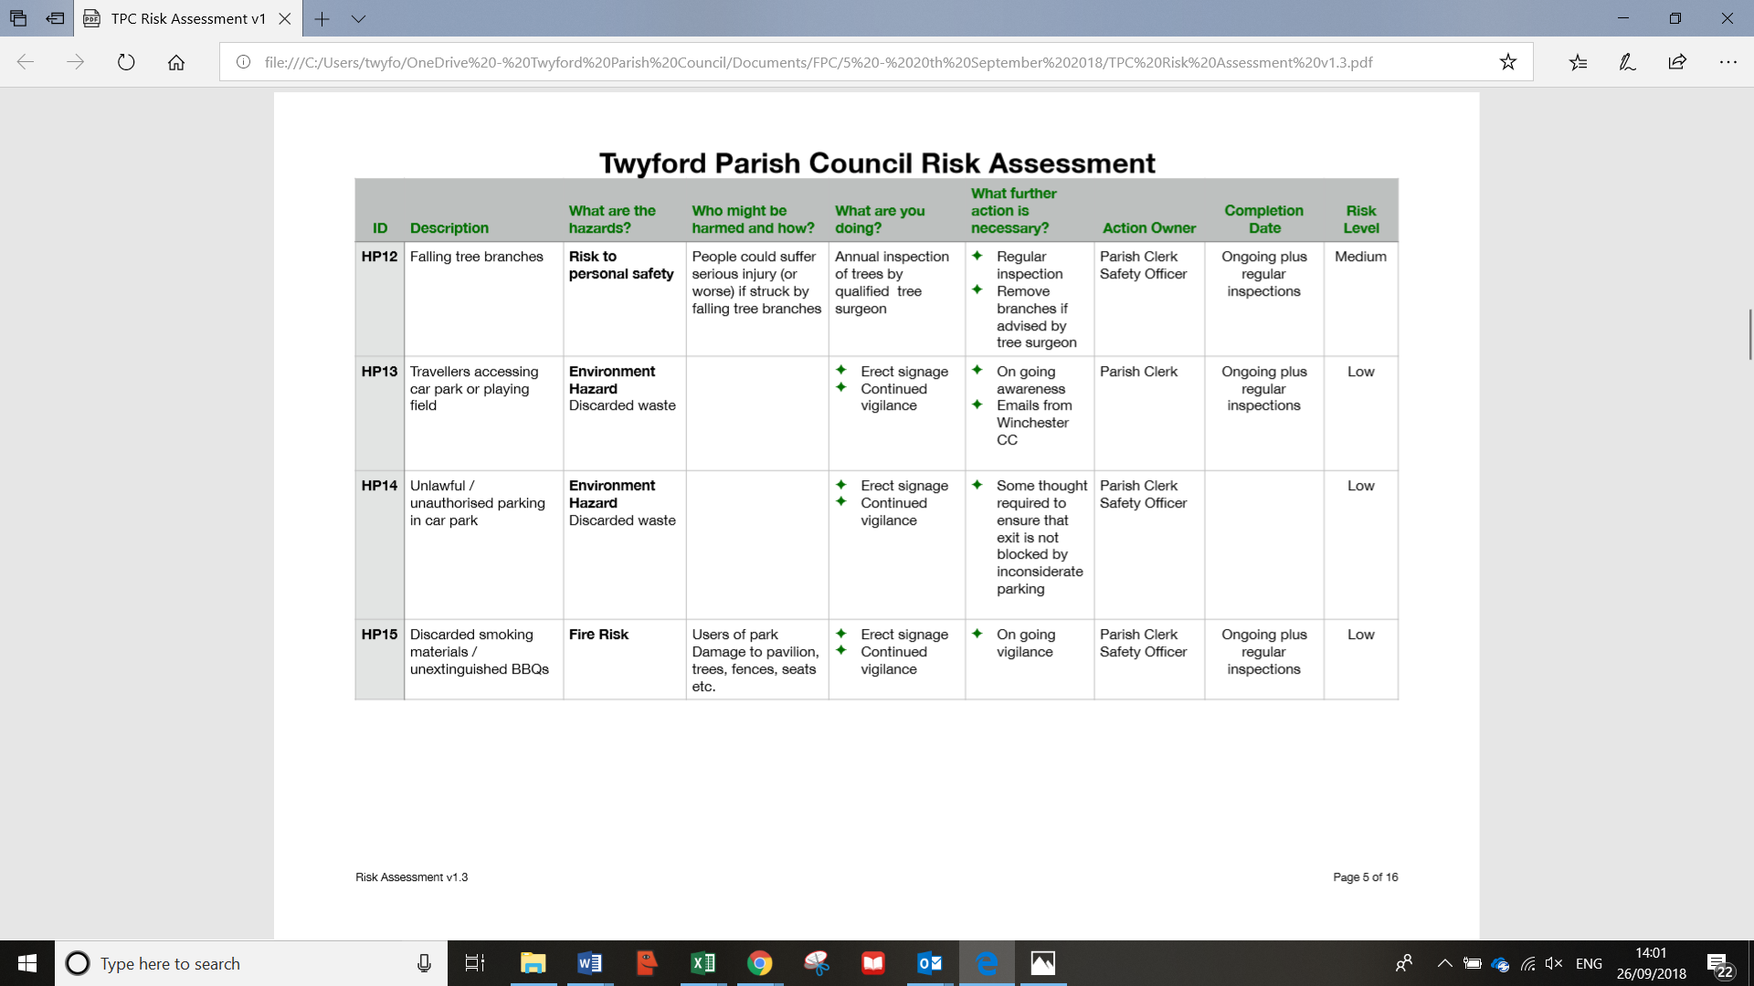

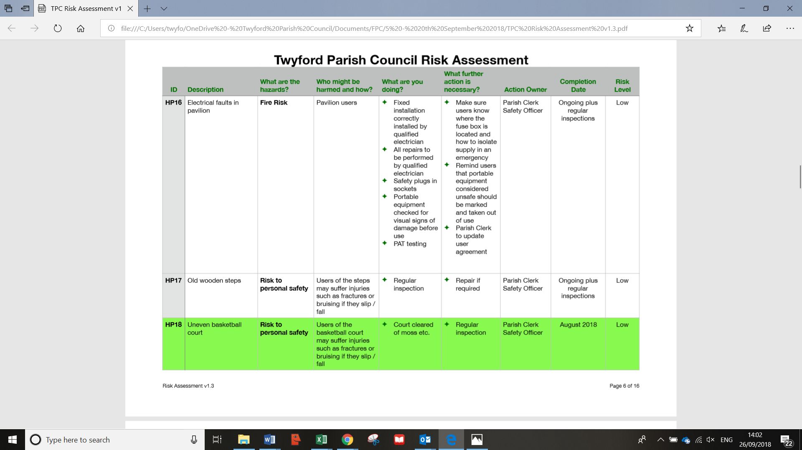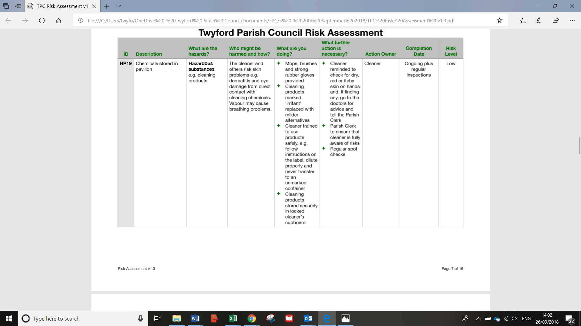
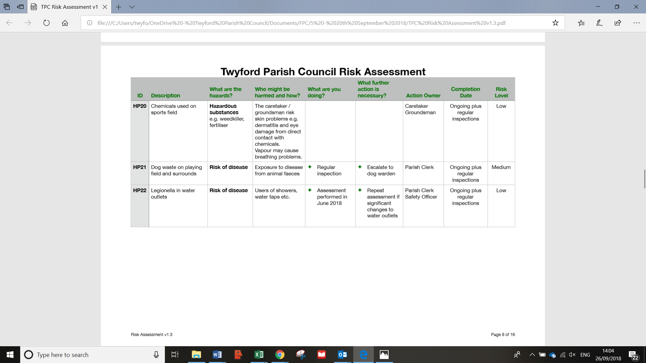
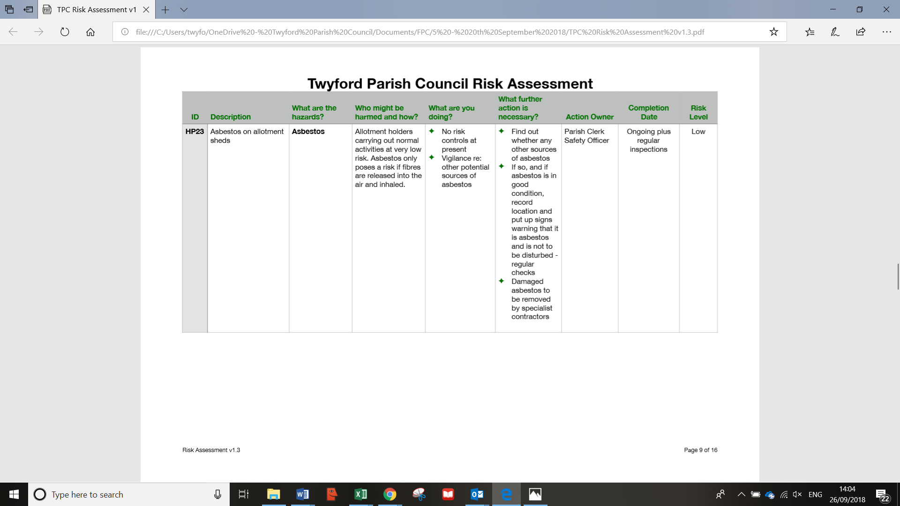
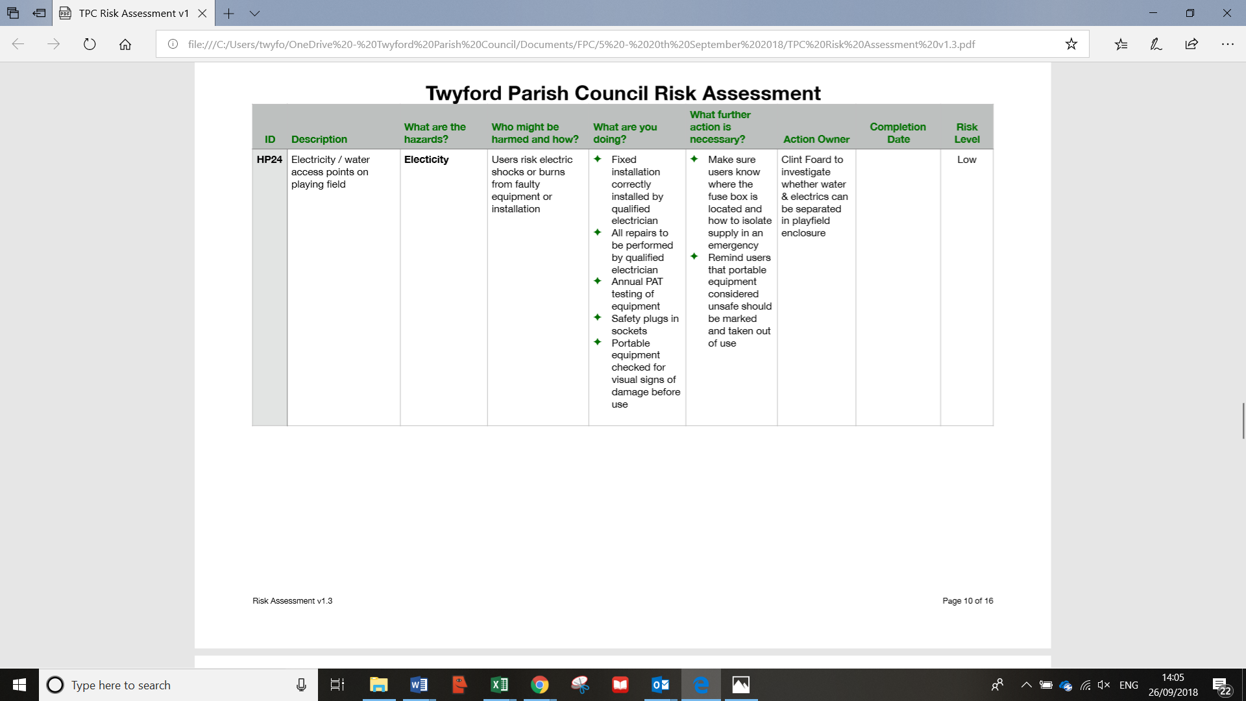
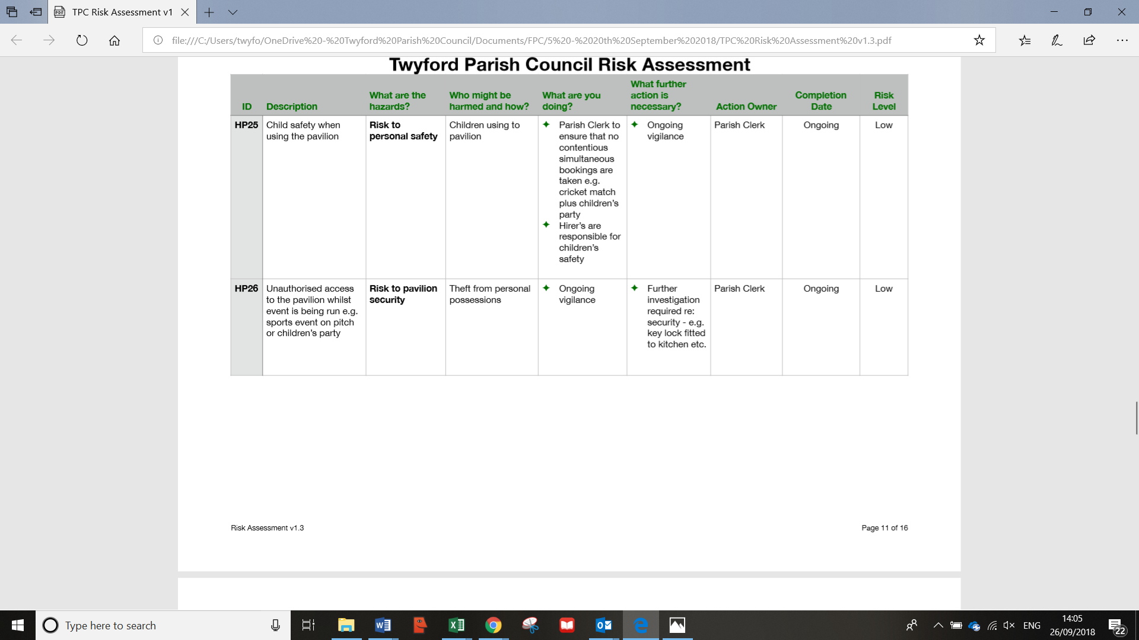
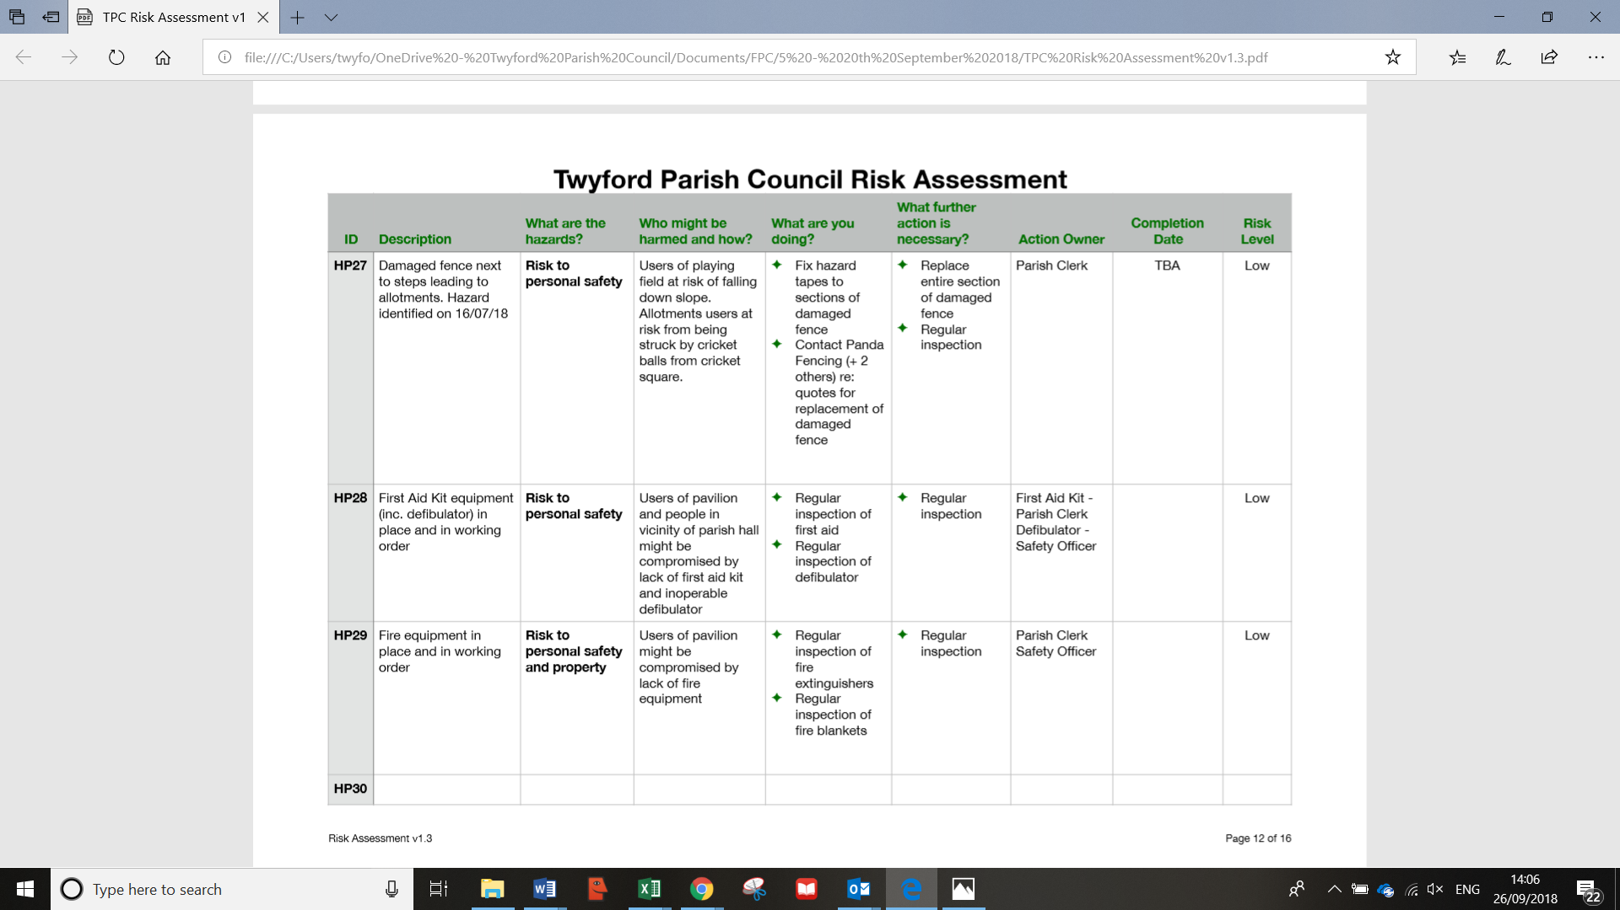
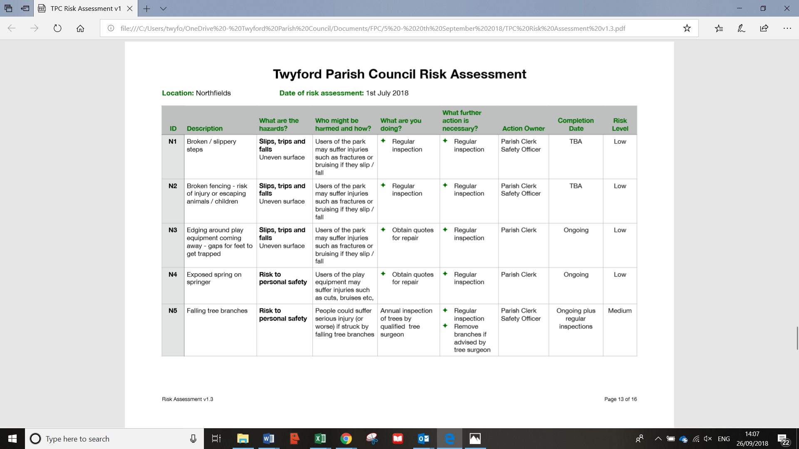
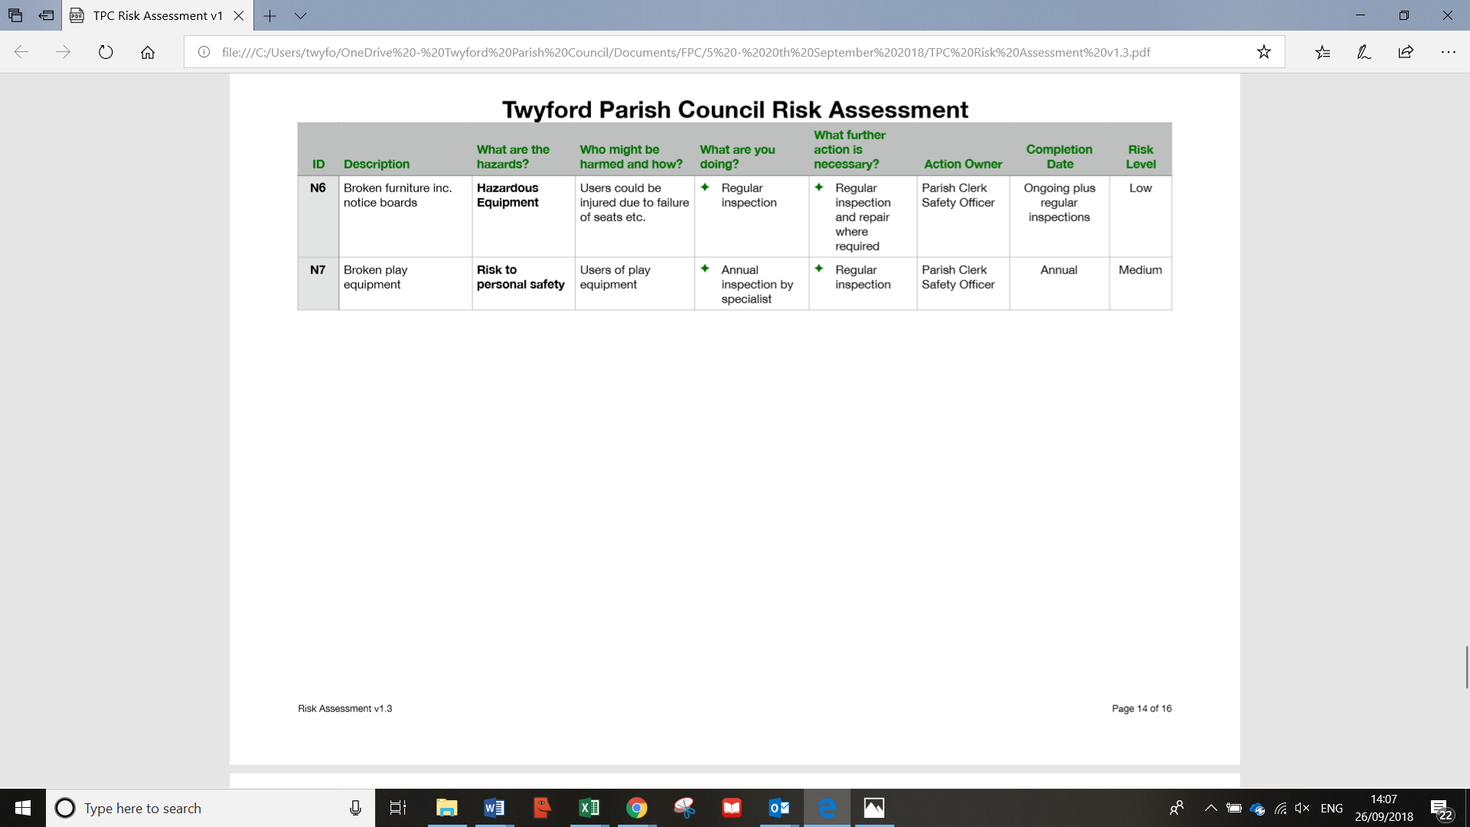
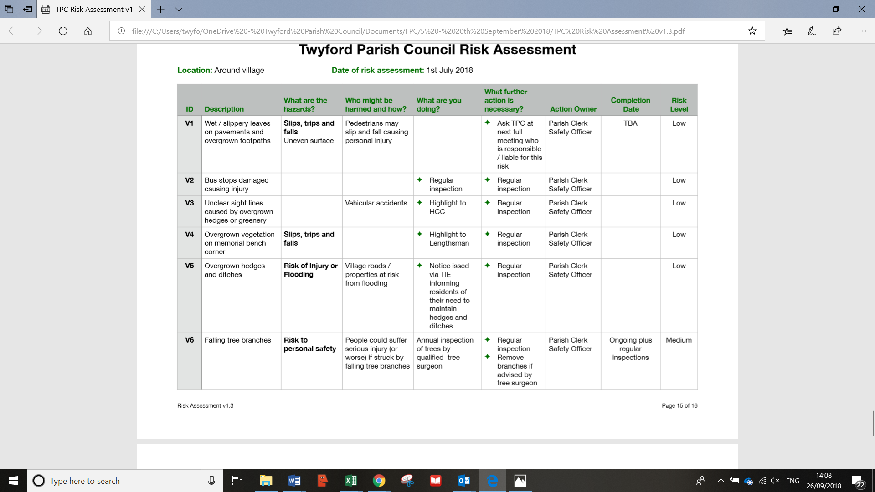
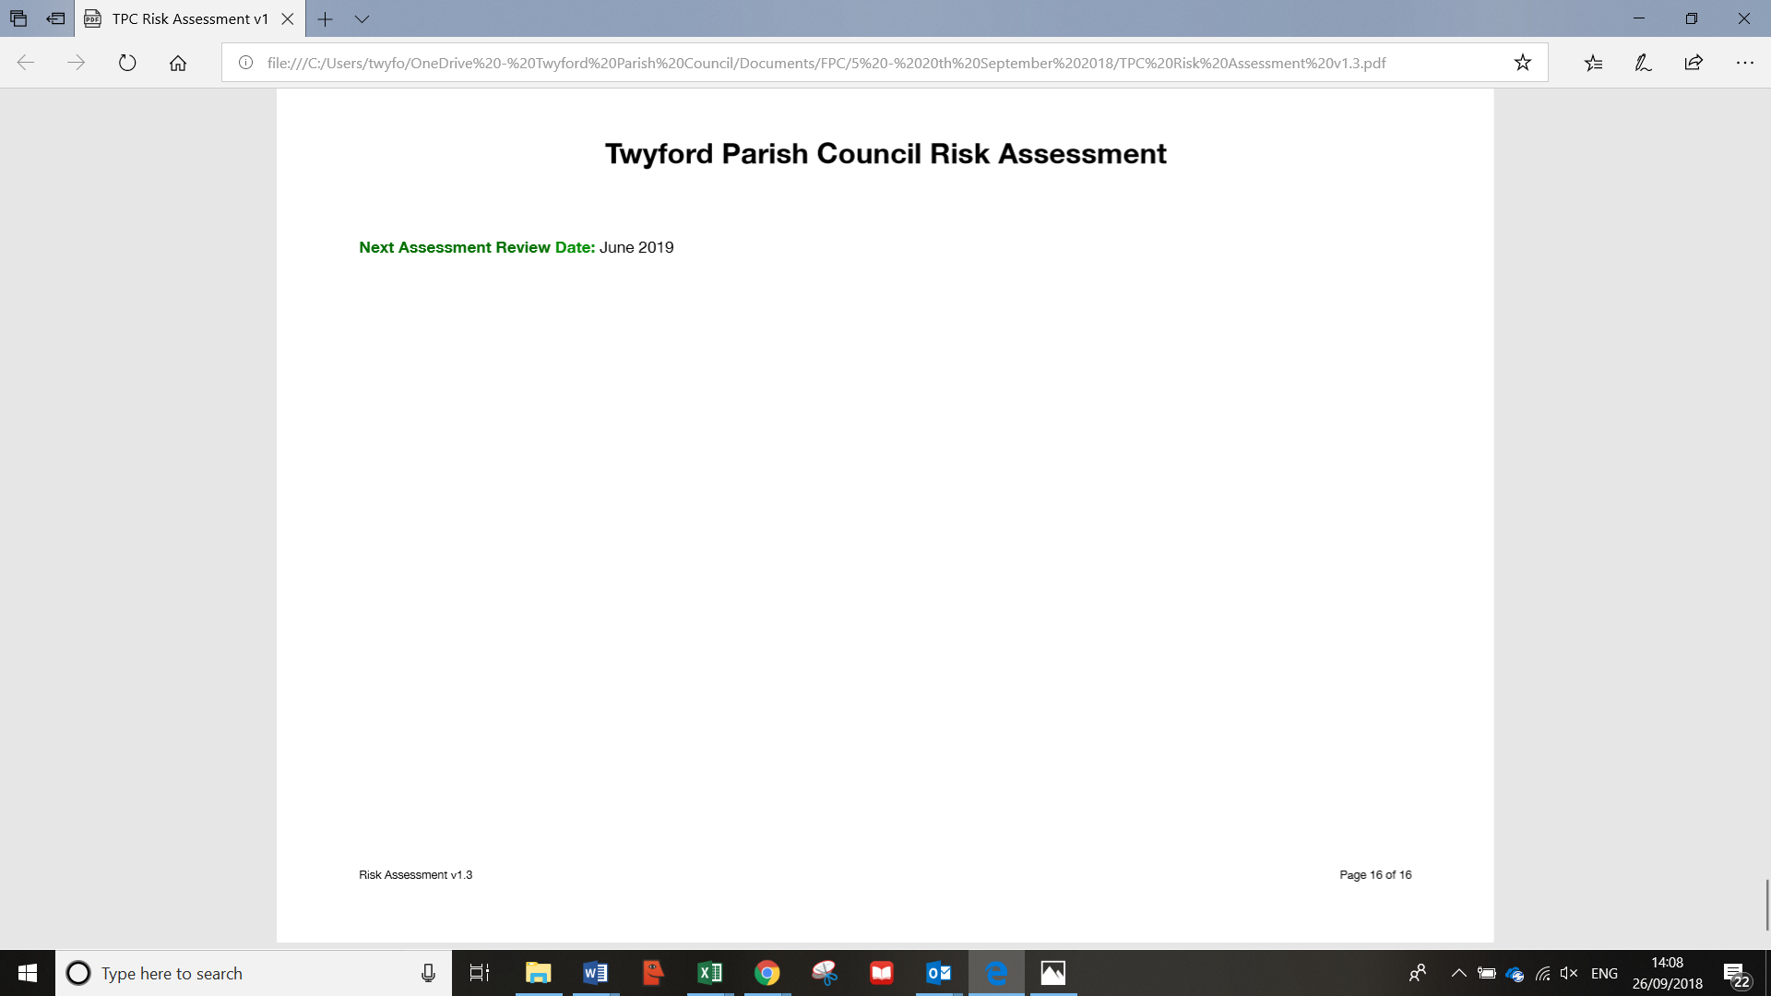

Appendix 2 – Previous Actions
Item | Action | Progress | Owner
 | 20th September 2018
103.1/18 | Correspondence received to request moving the weight limit sign of 7.5 tonnes from Mare Lane further up Hazeley Road, towards the village before Humphrey Farms. PC to progress and raise with Cllr Humby |  | PC
103.3/18 | Southampton Airport is set to double in size.  Action: Clerk to add to the Planning Committee 4th October |  | Clerk
105/18 | Clerk to send out update on NP on TIS following approval from Cllr Corcoran |  | Clerk
106.3/18 | Clerk to make final edit and submit comments on WLP Consultation.  Clerk to obtain the comments made by Colden Common on SHLAA Consultation and send to Cllr Corcoran and Cllr Lawton. |  | Clerk
110/18 | Insurance renewal: Cllr Cook to email Cllr Warwick to obtain an update, and explain delay in correspondence with Clerk and Cllr Mitchell  Clerk to obtain cover note for one month |  | SC  Clerk
113/18 | Clerk to send out TIS on developments at the lock and water meadows |  | Clerk
114/18 | Clerk to send Cllr Cook Edge IT contact number |  | Clerk
115/18 | Cllr Lawton to feedback to ADD the banners look out of date |  | WL
116/18 | Cllr Cook to follow up with Cllr Humby the progress on the hedge at Finches Lane  The corner of Finches Lane / Queen Street: Cllr Cook to contact Ivan Gurdler to assess the tree for cutting back. Cllr Cook to enquire about moving the dog bin away from the bench, and further up the bank. |  | SC  SC
 | 19th July 2018
79/18 | Cllr Mitchell to look up status of Highcroft and Hillcroft planning applications | 20.09.18: carried over | CM
83/18 | The production of a 5 year plan is supported, and the first step was agreed to be a completion of the top 10 priorities over the coming 5 year period. Clerk to email Cllrs requesting their priorities, and compile a list. | 20.09.18: 118/18: Cllrs to send Clerk thoughts by 30th September. Clerk to send all Cllrs a list of what has been received to date, excluding Cllr Cook, who would like to work from a blank canvas. | Clerk and All
84/18 | WiFi is being installed to the Parish Hall, but the Trustees may need support from the PC in taking out the contract. Clerk to add to next FPC agenda for an update from the Parish Hall Trustees | WiFi is installed. Closed | Clerk
85/18 | Issues regarding public liability at the lock were discussed  - Immediate action  Cllr Mitchell to put up a sign at the lock, with new wording to say TPC accept no liability. Cllr Mitchell to send a photo of the sign, and send to the Clerk. Clerk to send photo to insurers for their records.  - Intermediate action (to be done up until end of current insurance policy 30th September)  Cllr Lawton to set up a meeting with HCC Countryside, Cllr Rob Humby, and establish who owns what part of the lock.  - Longer term (at insurance renewal, 30th September)  Specify cover is required on the new policy, and await requirement from the new insurer.  A public meeting will be arranged for the spring, to discuss with villagers the ownership of the lock, liability and rubbish collection.  Clerk to add as an agenda item to the February 2019 FPC meeting. | 20.09.18. Done.  20.09.18. ongoing  20.09.18. ongoing  20.09.18. in diary. | CM  WL  Clerk  Clerk
87/18 | Cllr Pullen has compiled a draft H&S policy.  Clerk and Cllr Pullen to meet to review the risk assessments required.  Clerk to circulate H&S policy, and add sign off to the next FPC agenda Sept 2018 | 20.09.18. done. | Clerk  SP  Clerk
89/18 | Security access to the pavilion was discussed. Clerk to obtain quotes for automatic lights / timer light switches to prevent lights being left on  Clerk to change the lock access code at end of the cricket season, and inform relevant people | 20.09.18. code to be changed after 30.09.18 | Clerk  clerk
90/18 | Funding for the Berry Meadows Phase 2 project were discussed. Clerk to complete forms required to obtain the agreed funds from SDNPA  Cllr Corcoran to present to the TPC specific figures for each stream of work, with priorities | 20.09.18. ongoing | Clerk  CC
96a | TPC response on the Eastleigh Local Plan needs to be submitted. A separate meeting is to be set up for Cllr Cook, Cllr Lawton, Clerk and Cllr Corcoran to devise the response. Delegation was given for the response to be given on behalf of the Council. | 20.09.18. submitted by cllr Corcoran on time. Closed. | Clerk / WL / SC / CC
 | 21st June 2018
57.3/18 | Cllr Lawton to ask Stuart Gilmour to attend a FPC meeting to provide an update for Twyford. | 20.09.18. no response received. Ongoing | WL
60/18 | Clerk to obtain a quote from Alex Reidy to get the broken branches off the large trees, and raise the canopy at the football pitch, at Hunter Park | 20.09.18. work complete. closed | Clerk
62/18 | Clerk and Cllr Wheeler to investigate the water charges to Hunter Park, and whether a meter reading is due. | 20.09.18. carried over | Clerk and IW
63/18 | Cllr Sellars to meet with Clerk to reconcile the bank statements to payments made | 20.09.18. complete. closed | RS
64/18 | Clerk to resolve the outstanding issues with HPTA to enable the court resurfacing to commence | 20.09.18. complete. closed. | Clerk
65/18 | Clerk to ask Cllr Corcoran to obtain a cost for anti slip steps at the Lock, for approval at the next FPC meeting, 19th July.  Clerk to inform Cllr Corcoran to present the quotes for new gates at Berry Meadow, for approval at the next FPC, 19th July | 20.09.18. complete. Closed.  Requirements changed. Closed. | Clerk
66/18 | The developer has created updated plans for Site 26. Clerk to add TNP new version, and amended developer plans to be presented, on the next FPC agenda, 19th July | 20.09.18. ongoing | Clerk
67/18 | Public Transportation Consultation from WCC: Clerk to inform the village of the Consultation via TIS | 20.09.18. complete. Closed | Clerk
68/18 | The letters to residents from Cllr Lawton providing support to ADD have all been delivered, clerk to circulate to residents via TIS | 20.09.18. complete. Closed. | Clerk
69/18 | The “Appoint a Contractor” procedure has been updated, and it was resolved to adopt the procedure. Clerk to send to Cllr Pullen for procedure to be added to the website. | 20.09.18. complete. closed | Clerk / SP
 | Annual Meeting 24th May 2018
140/17 | Update on dog bins and whether more cost effective to move over to dual purpose bins | 21.06. Clerk emailed David Ingram 20.06.18 to chase progress. Ongoing  20.09.18. Clerk to send Cllr Cook an email on action taken to date, as no response from WCC (sent to SC 26.09.18) | Clerk
164/18 | Cllr Cook to update on costs of moving the telephone box and resolve to sign the adoption contract. Cllr Cook to present a written quotation to the Clerk (197/18). | 21.06. Cllr Cook is trying to progress. Ongoing  20.09.18. ongoing | SC
215/18 | Clerk to update on progress with Countryside, to repair the tarmac on footpath from Searle’s Hill to St Mary’s Church | 21.06. Clerk to email Helen Barber  20.09.18. Cllr Lawton had sent an email to head of country services regarding the tarmac path on Searle’s Hill, and has had no reply. The clerk has had no reply from Countryside services either. To be followed up. | Clerk
35/18 | Cllr Corcoran to review and amend the draft terms of reference for the Neighbourhood Plan technical team and send to clerk, to be approved at FPC. | 21.06. Carried over  20.09.18. carried over | CC
36/18 | Clerk to draft Subject Access Request procedure under GDPR legislation, and present to FPC for approval | 21.06. Carried over  20.09.18. carried over | Clerk
36/18 | Clerk to draft a procedure for dealing with press / media, and present to FPC for approval | 21.06. Carried over  20.09.18. carried over | Clerk
37/18 | Cllr Pullen will make the privacy policy under GDPR available on www.twyfordhants.org.uk | 21.06. Clerk to send to Cllr Pullen (done 27.06.2018). Ongoing.  20.09.18. done. Complete. | SP
39.3/18 | With regards to appointing Panda Fencing to install the Spinner. Cllr Cook to have sight of all paperwork, and provide confirmation to the Clerk. Once provided the work can commence. | 21.06. In progress.  20.09.18. ongoing | SC
47/18 | Cllr Lawton to write to Aqua Science to thank them for the work they have done at Compton Lock. | 21.06. To do. Clerk to send address to Cllr Lawton (done 27.06.2018).  20.09.18. done. Closed. | WL
47/18 | Cllr Corcoran to add signage to the project plan for the Berry Meadows, Phase 2. | 21.06. Update required from CC. outstanding.  20.09.18. done. Closed. | CC
48/18 | Clerk to specify what is required for Mayer Brown to provide to the Council, prior to the commencement of work of the Flood Mitigation Survey. | 21.06. Clerk has emailed our requirements to Mayer Brown. Awaiting them to respond with all requirements.  20.09.18. done. Closed. | Clerk
49/18 | Jonathan Humphrey’s team has painted the bus stop at Northfields; Chairman to write to Jonathan Humphrey expressing the gratitude of TPC. | 21.06. To do.  20.09.18. done. Closed. | WL
51.3/18 | HPTA to write to local residents informing them of the scope of the tennis court re-surfacing work, duration of the project, and times the work will be carried out. | 21.06. Ongoing. Clerk to follow up with HPTA  20.09.18. done. Closed. | Clerk
51.3/18 | HPTA to write an email to go out on TIS and TwaT informing residents of the planned resurfacing work, and the procedure for non members to book a court. | 21.06. Ongoing. Clerk to follow up with HPTA  20.09.18. procedure is ongoing. | Clerk
51.3/18 | Clerk to investigate the options of claiming back the VAT on any proportion of the work being commissioned by HPTA | 21.06. ongoing.  20.09.18. done. Closed. | Clerk
 | 19th April 2018
4.3/18 | With regards to the Section 106 money from Sandyfields development; Cllr Izard and Cllr Lawton to meet to agree how to move this forward, and submit request to improve roads in Twyford. | 21.06. WL waiting to hear from Cllr Izard. Clerk to email RI.  20.09.18. ongoing | WL
9/18 | Investigate further publishing wages, to ensure no conflict with the financial regulations, and to clarify how the Minute of the wages being paid did not comply with the recommendation. | Wages – carried over.  20.09.18. nothing picked up in audit. Closed. | Clerk
11/18 | More detail on Neighbourhood Plan spend pre April 2015 is also required, to be added to the year end accounts. | 2018. TNP spend carried over.  20.09.18. ongoing | Clerk
16/18 | Berry Meadows phase 2: Clerk to add Kathy Stearne recommended measures to FPC agenda 24th May 2018 | To do FPC 19th July 2018.  20.09.18. ongoing. | Clerk
16/18 | Clerk is able draw some of the £6,000 grant for the lock project from SDNPA. | 21.06. carried over  20.09.18. ongoing. | Clerk
17.1/18 | A local resident had cleared the ditch Finches Lane / Churchfields, but a grate in front of the ditch needs clearing. Clerk to contact HCC about clearing the grate in the ditch Finches Lane / Churchfields | 21.06. Clerk resent email to WCC on 21.06.18. Ongoing.  20.19.18. done. Closed. | Clerk
 | 15th March 2018
197/18 | Cllr Cook to email Cllr Humby to request Highways clear pavements near Colleton House and Searle’s Hill. | 21.06. ongoing  20.09.18. done. Closed | SC
197/18 | Cllr Cook the turf on corner of Finches Lane and Queen Street will be re-turfed by the builders. Cllr Cook to ask Neville Crisp if bollards can be put on the verge to stop vehicles from parking. | 21.06. ongoing  20.09.18. done. Closed. | SC
199.3/18 | It was agreed that the hire fees would be published on the website. Cllr Wheeler to provide some words to Cllr Pullen to be published on the website. | 21.06. Clerk to send the fees to Cllr Pullen (done 27.06.18)  20.09.18. done. Closed. | IW / SP
203/18 | If Councillor does not wish to receive the PC remuneration, they are to write to the Clerk. Clerk to publicise the remuneration availability | 21.06. Clerk to follow up with CC (emailed him 27.06.187), then publish policy.  20.09.18. clerk to publish on website and notice boards | CC / Clerk  clerk
205/18 | Clerk to investigate backing up files on the cloud | 21.06. Ongoing with GDPR IT solution.  20.09.18. done. Closed. | Clerk
 | 15th February 2018
180/18 | A request was made that if the access code to the key lock at the pavilion is updated, that a cascade procedure is formulated, so everyone concerned is informed. Clerk to write procedure | 21.06. carried over.  20.09.08. carried over. | Clerk
180/18 | Cllr Mitchell will test power washing the surface of the basketball court | 21.06. Greensmile to kill weeds, Caretaker to jet wash. Clerk to manage process.  20.09.18. done. Closed. | Clerk
183/18 | Cllr Sellars asked about the large concrete block under the water in the lock.  Action: Cllr Corcoran to investigate block being removed as part of the project works. | 21.06. Carried over. Clerk emailed CC 27.06.18 for update.  20.09.18. infeasible. Closed. | CC
190/18 | Cllr Forder-Stent reported that she had updated the flood action report, and the Clerk is to circulate. Cllr Forder-Stent to send Clerk report, and Clerk to circulate to PC. | 21.06. Clerk resent to Cllrs 21.06.18  Save document as Flood emergency contact document.  Check document name on website.  20.09.18. done. Closed. | Clerk
 | 25th January 2018
156.2/18 | Cllr Cook to request WCC take Norris Bridge down to one lane, with right of priority access heading out of Twyford, and pedestrians be allocated walkway down one side of the bridge. | 21.06. ongoing.  20.09.18. ongoing. | SC
163/18 | Cllr Mitchell enquired as to the benefit of the 7.5 ton weight limit sign outside the shop, which can only be seen from Finches Lane. Cllr Mitchell is contacting Neville Crisp to propose the sign to be removed | 21.06. CM to contact Neville Crisp.  20.09.18. new proposal received. Ongoing. | CM
172/18 | Cllr Wheeler updated that a van had been damaged by an overgrown hedge on the side of Finches Lane. Clerk to request Highways to take the hedge back to the wall | 21.06. Emails currently being exchanged on matter. Ongoing.  20.09.18. ongoing. | Clerk
 | 14th December 2018
149/17 | Clerk to send follow up letter to Segars Lane Riparian ditch owner | 21.06. This was done, but still no action has been taken. Clerk to follow up. Ongoing.  20.09.18. done. Closed. | Clerk
 | 21st September 2017
90/17 | Cllr West updated that she has been unable to progress the pollution testing, as has not been able to make contact with Jemma Barter. Clerk to find related emails, and Cllr Cook to make contact if required. | 21.06. Tubes cannot be located. Clerk contacted Jemma Barter for cost to purchase tubes. Ongoing.  20.09.18. Cllr Cook will speak to environment agency | Clerk  SC
93.2/17 | Action: Clerk to formulate a procedure for a quick response to an alert from WCC of travellers in the area. | 21.06. To do.  20.09.18. Clerk to request Colden Common cascade procedure | Clerk
 | 25th May 2017
41/17 |  | Clerk to find out who the contact at Highways is for Twyford – Clerk to request via Sue Cook or Rob Humby.  20.09.18. Closed. | Clerk.

Inhertited from previous Clerk

Matters Arising 23rd March 2016
184.2/16 | Cllr Lawton | Action - Councillor Lawton to write to HCC Councillor Peter Edgar (Leesland and Town) expressing concern about the potential impact on St Mary’s School. | 20 April | 21.06.18. More information required. Clerk to investigate further. Ongoing.  20.09.18. closed.

