TWYFORD PARISH COUNCIL
Minutes of a meeting of the Full Parish Council
held on Thursday 18th October 2018 at 7.30 p.m. in the Gilbert Room of Twyford Parish Hall

Councillors present | Councillors absent/apologies | In attendance
Councillor Lawton (Chair) | Councillor Humby | Jo Nicholson (Clerk)
Councillor Mitchell | Councillor West (Maternity Leave) | 3 members of public
Councillor Wheeler | Councillor Pain
Councillor Sellars | Councillor Izard
Councillor Pullen
Councillor Cook
Councillor Forder-Stent
Councillor Corcoran

Item | Business Transacted
121/18 | To receive and accept apologies for absence
 | Apologies were received from Cllr Pain, Cllr Izard, and Cllr West is on maternity leave.
122/18 | To receive declarations of interest relevant to agenda items
 | The registered declarations were applied.
123/18 | To approve and sign-off, as a true record, the minutes for the Full Parish Council meeting held on 20th September 2018
 | The minutes from 20th September 2018 were approved as a true record of events proposed by Cllr Forder-Stent and seconded by Cllr Wheeler
124/18 | To adjourn for public participation
124.1/18 | To receive questions from the members of the public.
Clerk | An update was provided on Graze Festival, by Roger Walker, one of the organisers. The rain this year resulted in much less ticket sales than previous years. The profit from the previous 3 years festival was required to fund the short fall in ticket sales. There are therefore no reserves left to help support a festival in 2019. The Parish Council was asked if they could provide circa £5,000 underwriting support of the event, and / or support in asking WCC the same question.  Cllr Cook asked if insurance would cover any losses in 2019 should it rain again. The response suggested that insurance does not cover ticket losses in event of rain, unless it can be proved Health and Safety of the public is at risk.  It was left for the Council to consider further, and understand the legal implications of providing financial support to a public event.  Action: Clerk to understand the powers the Council have to provide financial underwriting support to Graze Festival for 2019
124.2/18 | To receive the County Councillor’s report.
 | The County Councillor was absent
124.3/18 | To receive the District Councillors’ reports.
Cllr Corcoran / Clerk | Cllr Cook asked what the Parish Council were doing to respond to Southampton Airport Consultation on expansion plans. The Consultation was discussed at the Planning Committee on 4th October, where reasons to object were listed. It was agreed at that meeting, the Clerk would draft a response. The Clerk has also contacted SDNP to ensure it is on their radar to also object.  Cllr Mitchell asked whether Twyford should run a campaign similar to ADD to object to the plans. Cllr Corcoran informed that ADD will also be objecting to the plans, and therefore not necessary for TPC to take this on in addition. It was suggested that Twyford work with Colden Common, Bishopstoke, Swaythling, Woolston and New Forest as allies against the airport plans.  Action: Cllr Corcoran to send Clerk amendments to the draft Consultation response. Clerk to then send the TPC response to Southampton Airport, and circulate on TIS, and TwaT.  Cllr Cook also apologised for a photo in Touch magazine, and requested it be Minuted that she does not want politics to enter into the Parish Council. Cllr Lawton noted that the work of the Parish Council should not be taken to credit a political party.  Cllr Cook registered thanks to Matt Riley and Christine Hill for their work on Pumfrett’s Bank, to reveal the memorial stone. The work has already been noted by local residents. Cllr Lawton provided a legal update, the HCC solicitor representing TPC delivered a letter to the home owner’s solicitor on the same day the bank was cut. No correspondence or contact has been made / received since. The volunteer work should continue over Autumn, ready for Green Smile to fulfil through their contract in 2019.  Cllr Cook also attended a tour ran by WCC planning department, to view properties investigated by enforcement.
125/18 | To receive an update on matters arising from the minutes of the Full Council meeting held on 20th September 2018 that are not included elsewhere on the agenda and to consider the status of progress to date
Clerk | The Parish Council insurance was extended until 19th October, to enable a decision to be made at the FPC meeting tonight. The insurance company have offered insurance now to include public liability at the lock, with 4 conditions:  - Follow the advice from a professional body on how to manage the area and the management of the water  - Seek legal advice about the case law provided and the Councils responsibility because of the case law  - Seek further advice regarding the signage and if necessary update  - Update required within 30 days on above subjectivities on progress  A discussion followed considering avenues to fulfil condition 1, which involved utilising testing by the EA, and Southern Water.  A sign will need to convey a message in a positive manner. Cllr Warwick has previously mentioned she may be able to help with funds for a sign.  Action: Clerk to look in detail at what is required on return from holiday, w/c 29th October, and recommend actions for next FPC, 22nd November  It was agreed for the insurance to be renewed with Came and Company, being underwritten by Hiscox, on a 3 year deal. Proposed by Cllr Lawton, and seconded by Cllr Forder-Stent.
126/18 | Councillor Corcoran to provide an update on progress of the Neighbourhood Plan and agree to publish an update on progress
Cllr Corcoran / Clerk | The Environment Assessment has moved forward slightly, in that amends have been agreed with SDNP. When the final report has been received by TNP, it will be circulated to TPC.  The TNP is being redrafted to take into account the SDNP’s Plan.  Prior to the TNP being published for pre-submission Consultation, the plan will need to be reviewed by the EA assessor to ensure it complies with their assessment. Prior to this, the plan will come to the TPC for approval.  The flood mitigation survey results are due at end of October.  There is a new development which may impact the TNP, the HRA (Habitat Regulation Assessment) procedure has recently been challenged, which means the HRA already done on TNP may need to be redone / changed.  A communication to the Parish providing an update on progress needs to be published. The Clerk has sent a draft TIS to Cllr Corcoran.  Action: Cllr Corcoran to amend Clerk’s draft email, and Clerk to circulate on TIS
127/18 | To receive an update from the Planning Committee and any updates on any matters arising unless already covered by another agenda item
 | The minutes have been published online and circulated. The main point of discussion was the Airport Consultation. Cllr Lawton also updated that he and Cllr Mitchell are meeting Jonathan Humphreys regarding the proposed retirement home development at Hazeley Farm.
128/18 | To receive an update from the Finance Committee on matters arising; and to note or discuss action taken since unless already covered by another agenda item
 | Matters covered by items 129/18 to 132/18
129/18 | Resolve to approve payments to be made in October 2018
The payments to be made in October were reviewed and discussed.
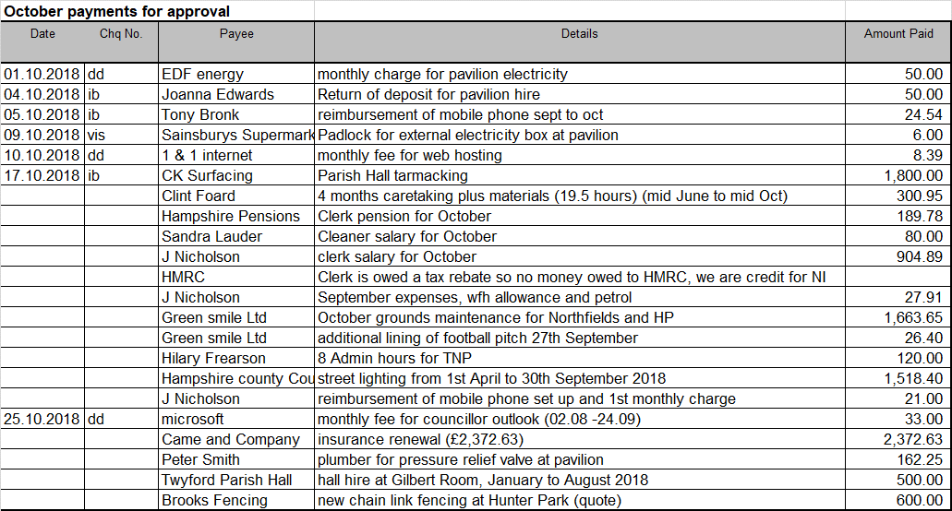
It was resolved to make the payments, proposed by Cllr Mitchell and seconded by Cllr Pullen.
130/18 | Resolve to approve the Q2 financials, and note year end forecast.
Clerk | The Q2 financial were reviewed in detail (see Appendix 1), noting that financials are tracking to budget.  The financials were approved, proposed by Cllr Pullen and seconded by Cllr Mitchell.  Action: Clerk to add flood mitigation financials to FPC agenda 22nd November
131/18 | Resolve to approve withdrawal of £800 of funds from Parish Council bank account, held on behalf of TIW Ltd.
 | Andy Coates provided an update on TIW Ltd accounts, and that the Parish Council hold £1,587 of funds on behalf of TIW. The funds have been accumulated by deposits from RPA, which is split between the Water Meadow and TIW, to be used on maintenance. There is an AGM on 3rd December, for shareholders of TIW Ltd. It was resolved to transfer the £800 to TIW Ltd, proposed by Cllr Lawton and seconded by Cllr Wheeler.
132/18 | Review the 5 year plan priorities, and identify funding priorities for budget setting 2019 / 2020.
 | The Clerk had sent around a list of the Parish Councillors’ job / project list for the next 5 years. PC’s have been requested to highlight their top priorities, so a final list can be created for budget setting. Action: PCs’ to send Clerk top priorities by 29th October
133/18 | To receive an update on matters arising from the Recreation Committee; to note or discuss action taken since unless already covered by another agenda item
The vacancy for the cricket groundsman has been advertised, and responses are due by the 9th November.
The School PTA are organising a fireworks display at Hunter Park on 11th November. The display will be Remembrance Day themed, and appropriate to Remembrance Sunday. No banners will be used at the memorial bench. It was highlighted by Cllrs that complaints may be received regarding fireworks at the park, and on the specific date due to it being Remembrance Day.
Action: Cllr Wheeler to request the PTA issue a communication to residents via delivered letters, and issue a communication on TIS explaining the event and the connection to Remembrance day.
134/18 | Councillor Corcoran to provide an update on Berry Meadow & Compton Lock Committee.  1.Resolve to approve quote for £300 from Kathy Stearne for preparing a specification for the further works to the Meads  2. Agree to send the spec out to three firms requesting quotations.  3. Agree to utilise the quotes once received as a basis for obtaining further grants .
As the Water Meadows keep deteriorating, and the damage has yet to be repaired from the 2004 floods, work on the Water Meadow project continues. The next phase is for KIS Landscapes to specify the work required to repair the channels. The work by Kathy Stearne will cost £300. It was resolved to approve the expenditure, proposed by Cllr Corcoran and seconded by Cllr Cook.
The next phase to obtain quotes was agreed.
135/18 | Consider status of footpaths, byways and pavements, and report any required maintenance required. Identify priorities for lengthsman visit w/c 7th November 2018.
Cllr Lawton | The repair work to the tarmac on Searle’s Hill footpath has yet to be agreed. Cllr Lawton is continuing to contact the Head of Country Services, but has not been able to speak to anyone.  Action: Cllr Lawton to continue to contact Head of Country Services and copy in Cllr Cook  The B335 pavement from Northfields bus stop through to Hockley traffic lights needs overgrowth cut back. Cllr Cook has requested Cllr Humby to action the work required.  The Lengthsman next visit is 7th November, and work priorities were discussed. Clearing pavements and ditches around the village was identified as the priority, and the job sheet was completed during the meeting.
136/18 | Public Transport and Bus Stops – To receive an oral report from Councillor Wheeler
 | Progress will be reported at FPC 22nd November.
137/18 | Agree to support ADD seek further funds through another village letter distribution
ADD are requesting a further letter drop to Twyford residents, seeking financial support for the campaign. The proposed letter was considered too long, and a small leaflet was considered more appropriate.
Action: Cllr Lawton to work with ADD on a leaflet
138/18 | Review progress to date on previous FPC meeting outstanding actions
Cllr Cook | Actions were discussed and updates attached, see Appendix 2.  Action: Cllr Cook to speak to Cllr Humby regarding 103.1/18 (weight restriction sign being moved on Hazeley Road)
139/18 | To note, for information only, significant communications on matters that are not included elsewhere on the agenda
Cllr Lawton spoke to Phil Tidridge regarding pollution testing kits. The work done a few years ago would have been meaningless, as the tubes were in the wrong place. There is currently a test in place in the village, by The Bugle. Phil is happy to assist the Council put in place additional tubes, 6 would be required at £12 each. The tubes would need to be in place for 1 year, and need to be adjusted to get the correct analysis. It was considered that as traffic is one of the main issues in the village, it would be important to have these in place.
Action: Clerk to add to FPC agenda 22nd November for a resolution to provide financial and time support to implement pollution testing.
Cllr Cook has received a few complaints regarding Twyford School not using the pedestrian crossing, when walking children across to the Church. The safety considerations were discussed, and it was appreciated that crossing at the point they have used is likely to be safer than walking all the children up to the crossing.
Action: Cllr Cook to feed back to the resident that this is being done for safety reasons of the children and therefore to be supportive of the route taken by the School.
140/18 | To raise any items for the agenda for the Full Parish Council meeting 22nd November 2018
 | Propose pollution testing kit is purchased, and review flood mitigation financials.

Jo Nicholson - Clerk to the Parish Council – 30th October 2018. Contact: clerk@twyfordhants.org.uk

Appendix 1
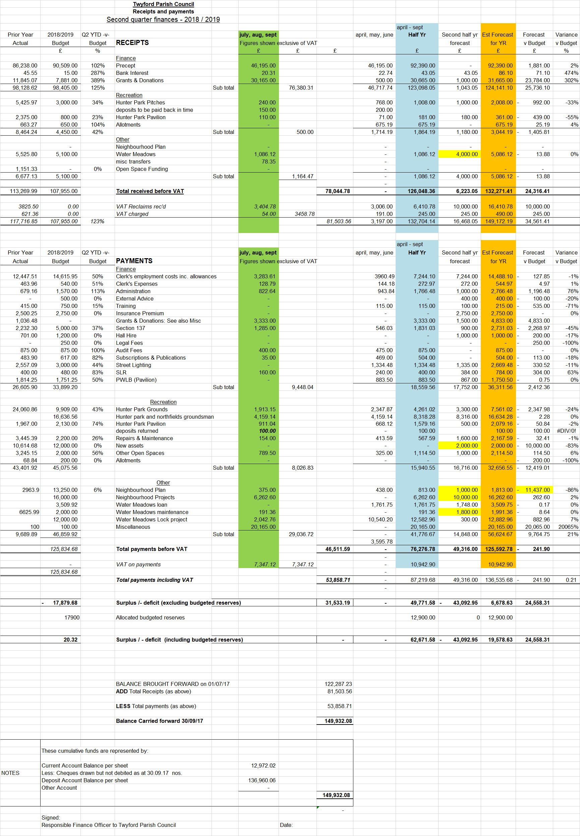
Appendix 2
Item | Action | Progress | Owner
 | 18th October 2018
124.1/18 | Clerk to understand the powers the Council has to provide financial underwriting support to Graze Festival for 2019 |  | Clerk
125/18 | The insurance company have offered insurance now to include public liability at the lock, with 4 conditions:  - Follow the advice from a professional body on how to manage the area and the management of the water  - Seek legal advice about the case law provided and the councils responsibility because of the case law  - Seek further advice regarding the signage and if necessary update  - Update required within 30 days on above subjectivities on progress  Clerk to look in detail at what is required on return from holiday, w/c 29th October, and recommend actions for next FPC, 22nd November |  | Clerk
126/18 | TNP update to Parish; Cllr Corcoran to amend Clerk’s draft email, and Clerk to circulate on TIS |  | CC & Clerk
130/18 | Clerk to add flood mitigation financials to FPC agenda 22nd November |  | Clerk
132/18 | The Clerk had sent around a list of the Parish Councillors’ job / project list for the next 5 years. PC’s have been requested to highlight their top priorities, so a final list can be created for budget setting. PCs’ to send Clerk top priorities by 29th October |  | All
133/18 | Cllr Wheeler to request the PTA issue a communication to residents via delivered letters and TIS explaining the event, and the connection to Remembrance day. |  | IW
135/18 | Cllr Lawton to continue to contact Head of County Services to address re-tarmacking footpath on Searle’s Hill |  | WL
137/18 | Cllr Lawton to work with ADD on a leaflet, to be delivered to residents |  | WL
139/18 | Clerk to add purchasing pollution kit (6 x £12), and time commitment, to FPC agenda 22nd November for a resolution |  | Clerk
139/18 | Cllr Cook has received complaint that Twyford School are not using the pedestrian crossing to access the Church. Cllr Cook to feed back to the resident that this is being done for safety reasons and therefore to be supportive of the action. |  | SC
 | 20th September 2018
103.1/18 | Correspondence received to request moving the weight limit sign of 7.5 tonnes from Mare Lane further up Hazeley Road, towards the village before Humphrey Farms. PC to progress and raise with Cllr Humby | 18.10.18. SC to raise with Rob Humby | PC
103.3/18 | Southampton Airport is set to double in passenger use  Action: Clerk to add to the Planning Committee 4th October | 18.10.18 - done | Clerk
105/18 | Clerk to send out update on NP on TIS following approval from Cllr Corcoran | To be complete 19.10.18 | Clerk
106.3/18 | Clerk to make final edit and submit comments on WLP Consultation.  Clerk to obtain the comments made by Colden Common on SHLAA Consultation and send to Cllr Corcoran and Cllr Lawton. | 18.10.18. done | Clerk
110/18 | Insurance renewal: Cllr Cook to email Cllr Warwick to obtain an update, and explain delay in correspondence with Clerk and Cllr Mitchell  Clerk to obtain cover note for one month | 18.10.18. done | SC  Clerk
113/18 | Clerk to send out TIS on developments at the lock and water meadows | 18.10.18. done | Clerk
114/18 | Clerk to send Cllr Cook Edge IT contact number | 18.10.18. SC emails sorted | Clerk
115/18 | Cllr Lawton to feedback to ADD the banners look out of date | 18.10.18. done. | WL
116/18 | Cllr Cook to follow up with Cllr Humby the progress on the hedge at Finches Lane  The corner of Finches Lane / Queen Street: Cllr Cook to contact Ivan Gurdler to assess the tree for cutting back. Cllr Cook to enquire about moving the dog bin away from the bench, and further up the bank. | 18.10.2018. SC has raised with Ray Gardner, gone over 28 days  18.10.18. IG has visited, and is on case. DIngram on case of moving the bin | SC  SC
 | 19th July 2018
79/18 | Cllr Mitchell to look up status of Highcroft and Hillcroft planning applications | 20.09.18: carried over  18.10.2018. Hillcroft is approved | CM
83/18 | The production of a 5 year plan is supported, and the first step was agreed to be a completion of the top 10 priorities over the coming 5 year period. Clerk to email Cllrs requesting their priorities, and compile a list. | 20.09.18: 118/18: Cllrs to send Clerk thoughts by 30th September. Clerk to send all Cllrs a list of what has been received to date, excluding Cllr Cook, who would like to work from a blank canvas.  18.10.2018. Cllrs to send Clerk their scores on top priorities by 29.10.18 | Clerk and All
85/18 | Issues regarding public liability at the lock were discussed  - Immediate action  Cllr Mitchell to put up a sign at the lock, with new wording to say TPC accept no liability. Cllr Mitchell to send a photo of the sign, and send to the Clerk. Clerk to send photo to insurers for their records.  - Intermediate action (to be done up until end of current insurance policy 30th September)  Cllr Lawton to set up a meeting with HCC Countryside, Cllr Rob Humby, and establish who owns what part of the lock.  - Longer term (at insurance renewal, 30th September)  Specify cover is required on the new policy, and await requirement from the new insurer.  A public meeting will be arranged for the spring, to discuss with villagers the ownership of the lock, liability and rubbish collection.  Clerk to add as an agenda item to the February 2019 FPC meeting. | 20.09.18. Done.  20.09.18. ongoing  18.10.18. done  20.09.18. ongoing  18.10.18. received – new action item  20.09.18. in diary. | CM  WL  Clerk  Clerk
89/18 | Security access to the pavilion was discussed. Clerk to obtain quotes for automatic lights / timer light switches to prevent lights being left on  Clerk to change the lock access code at end of the cricket season, and inform relevant people | 20.09.18. code to be changed after 30.09.18. 18.10.18. done | Clerk  clerk
90/18 | Funding for the Berry Meadows Phase 2 project were discussed. Clerk to complete forms required to obtain the agreed funds from SDNPA  Cllr Corcoran to present to the TPC specific figures for each stream of work, with priorities | 20.09.18. ongoing  18.10.18. ongoing | Clerk  CC
 | 21st June 2018
57.3/18 | Cllr Lawton to ask Stuart Gilmour to attend a FPC meeting to provide an update for Twyford. | 20.09.18. no response received. Ongoing  18.10.18. Cops and Coffee happening 1st Nov. | WL
62/18 | Clerk and Cllr Wheeler to investigate the water charges to Hunter Park, and whether a meter reading is due. | 20.09.18. carried over | Clerk and IW
66/18 | The developer has created updated plans for Site 26. Clerk to add TNP new version, and amended developer plans to be presented, on the next FPC agenda, 19th July | 20.09.18. ongoing | Clerk
 | Annual Meeting 24th May 2018
140/17 | Update on dog bins and whether more cost effective to move over to dual purpose bins | 21.06. Clerk emailed David Ingram 20.06.18 to chase progress. Ongoing  20.09.18. Clerk to send Cllr Cook an email on action taken to date, as no response from WCC (sent to SC 26.09.18)  18.10.18. Cllr Cook sent to D Ingram, who is working on it | Clerk
164/18 | Cllr Cook to update on costs of moving the telephone box and resolve to sign the adoption contract. Cllr Cook to present a written quotation to the Clerk (197/18). | 21.06. Cllr Cook is trying to progress. Ongoing  20.09.18. ongoing  18.10.2018. ongoing | SC
215/18 | Clerk to update on progress with Countryside, to repair the tarmac on footpath from Searle’s Hill to St Mary’s Church | 21.06. Clerk to email Helen Barber  20.09.18. Cllr Lawton had sent an email to head of country services regarding the tarmac path on Searle’s Hill, and has had no reply. The clerk has had no reply from Countryside services either. To be followed up.  18.10.18. ongoing. Cllr Lawton to copy in SC (135/18) | Clerk
35/18 | Cllr Corcoran to review and amend the draft terms of reference for the Neighbourhood Plan technical team and send to clerk, to be approved at FPC. | 21.06. Carried over  20.09.18. carried over  18.10.18. carried over | CC
36/18 | Clerk to draft Subject Access Request procedure under GDPR legislation, and present to FPC for approval | 21.06. Carried over  20.09.18. carried over  18.10.18. carried over | Clerk
36/18 | Clerk to draft a procedure for dealing with press / media, and present to FPC for approval | 21.06. Carried over  20.09.18. carried over  18.10.18. carried over | Clerk
39.3/18 | With regards to appointing Panda Fencing to install the Spinner. Cllr Cook to have sight of all paperwork, and provide confirmation to the Clerk. Once provided the work can commence. | 21.06. In progress.  20.09.18. ongoing  18.10.2018. to be installed monday | SC
51.3/18 | HPTA to write an email to go out on TIS and TwaT informing residents of the planned resurfacing work, and the procedure for non members to book a court. | 21.06. Ongoing. Clerk to follow up with HPTA  20.09.18. procedure is ongoing. | Clerk
 | 19th April 2018
4.3/18 | With regards to the Section 106 money from Sandyfields development; Cllr Izard and Cllr Lawton to meet to agree how to move this forward, and submit request to improve roads in Twyford. | 21.06. WL waiting to hear from Cllr Izard. Clerk to email RI.  20.09.18. ongoing  18.10.18. ongoing | WL
11/18 | More detail on Neighbourhood Plan spend pre April 2015 is also required, to be added to the year end accounts. | 2018. TNP spend carried over.  20.09.18. ongoing | Clerk
16/18 | Berry Meadows phase 2: Clerk to add Kathy Stearne recommended measures to FPC agenda 24th May 2018 | To do FPC 19th July 2018.  20.09.18. ongoing. | Clerk
16/18 | Clerk is able draw some of the £6,000 grant for the lock project from SDNPA. | 21.06. carried over  20.09.18. ongoing. | Clerk
 | 15th March 2018
203/18 | If Councillor does not wish to receive the PC remuneration, they are to write to the Clerk. Clerk to publicise the remuneration availability | 21.06. Clerk to follow up with CC (emailed him 27.06.187), then publish policy.  20.09.18. clerk to publish on website and notice boards | CC / Clerk  clerk
 | 15th February 2018
180/18 | A request was made that if the access code to the key lock at the pavilion is updated, that a cascade procedure is formulated, so everyone concerned is informed. Clerk to write procedure | 21.06. carried over.  20.09.08. carried over. | Clerk
 | 25th January 2018
156.2/18 | Cllr Cook to request WCC take Norris Bridge down to one lane, with right of priority access heading out of Twyford, and pedestrians be allocated walkway down one side of the bridge. | 21.06. ongoing.  20.09.18. ongoing. | SC
163/18 | Cllr Mitchell enquired as to the benefit of the 7.5 ton weight limit sign outside the shop, which can only be seen from Finches Lane. Cllr Mitchell is contacting Neville Crisp to propose the sign to be removed | 21.06. CM to contact Neville Crisp.  20.09.18. new proposal received. Ongoing. | CM
172/18 | Cllr Wheeler updated that a van had been damaged by an overgrown hedge on the side of Finches Lane. Clerk to request Highways to take the hedge back to the wall | 21.06. Emails currently being exchanged on matter. Ongoing.  20.09.18. ongoing. | Clerk
 | 21st September 2017
90/17 | Cllr West updated that she has been unable to progress the pollution testing, as has not been able to make contact with Jemma Barter. Clerk to find related emails, and Cllr Cook to make contact if required. | 21.06. Tubes cannot be located. Clerk contacted Jemma Barter for cost to purchase tubes. Ongoing.  20.09.18. Cllr Cook will speak to environment agency  18.10.18. new item 139/18 | Clerk  SC
93.2/17 | Action: Clerk to formulate a procedure for a quick response to an alert from WCC of travellers in the area. | 21.06. To do.  20.09.18. Clerk to request Colden Common cascade procedure | Clerk

